





**RAJALAKSHMI ENGINEERING COLLEGE (AUTONOMOUS)**

**RAJALAKSHMI NAGAR, THANDALAM ** **602 105 BONAFIDE CERTIFICATE**

NAME: GIRIDHARAN D REGISTER NO.: 231001044

ACADEMIC YEAR 2024-25 **SEMESTER**- IV **BRANCH**: B. Tech Information

Technology [AD/AE]. This Certification is the Bonafide record of work done by the above student in the **CS23432**- **Software Construction** Laboratory during the year 2024-2025.

Signature of Faculty -in  Charge

Submitted for the Practical Examination held on

Internal Examiner External Examiner



**LAB PLAN**

**CS23432-SOFTWARE CONSTRUCTION LAB**

|  |  |  |  |  |
| --- | --- | --- | --- | --- |
| **Ex No** | **Date** | **Topic** | **Page No** | **Sign** |
| 1 | 21/01/2025 | Study of Azure DevOps |  |  |
| 2 | 28/01/2025 | Problem Statement |  |  |
| 3 | 04/02/2025 | Agile Planning |  |  |
| 4 | 18/02/2025 | Create User stories with Acceptance Criteria |  |  |
| 5 | 25/02/2025 | Designing Sequence Diagrams using Azure DevOps-WIKI |  |  |
| 6 | 04/03/2025 | Designing Class Diagram using Azure DevOps- WIKI |  |  |
| 7 | 11/03/2025 | Designing Use case Diagram using Azure DevOps- WIKI |  |  |
| 8 | 18/03/2025 | Designing Activity Diagrams using Azure DevOps- WIKI |  |  |
| 9 | 25/03/2025 | Designing Architecture Diagram Using Star UML |  |  |
| 10 | 01/04/2025 | Design User Interface |  |  |
| 11 | 08/04/2025 | Implementation – Design a Web Page based on Scrum Methodology |  |  |
| 12 | 15/04/2025 | Testing-Test Plan, Test Case and Load Testing |  |  |



**Aim:**

To set up and access the Azure DevOps environment by creating an organization through the Azure portal.

**INSTALLATION**

1. Open your web browser and go to the Azure website: [https://azure.microsoft.com/en-us/get-](https://azure.microsoft.com/en-us/get-started/azure-portal) [started/azure-portal](https://azure.microsoft.com/en-us/get-started/azure-portal).

Sign in using your Microsoft account credentials.

If you don't have a Microsoft account, you can create one here: <https://signup.live.com/?lic=1>

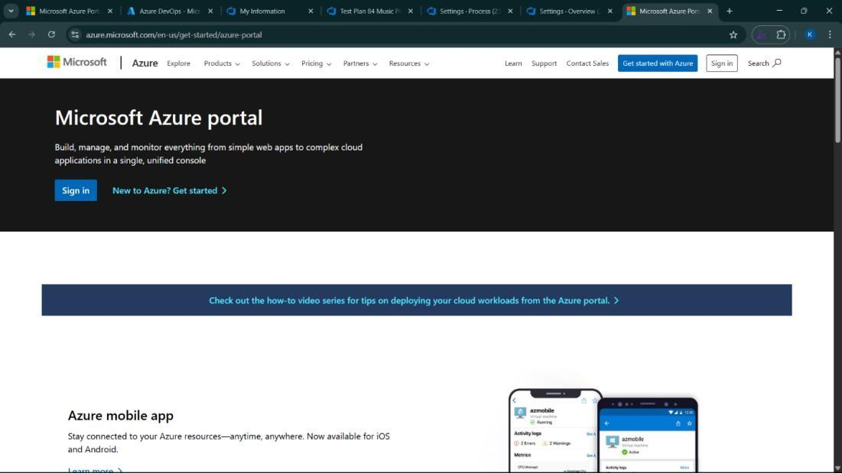

1. Azure home page

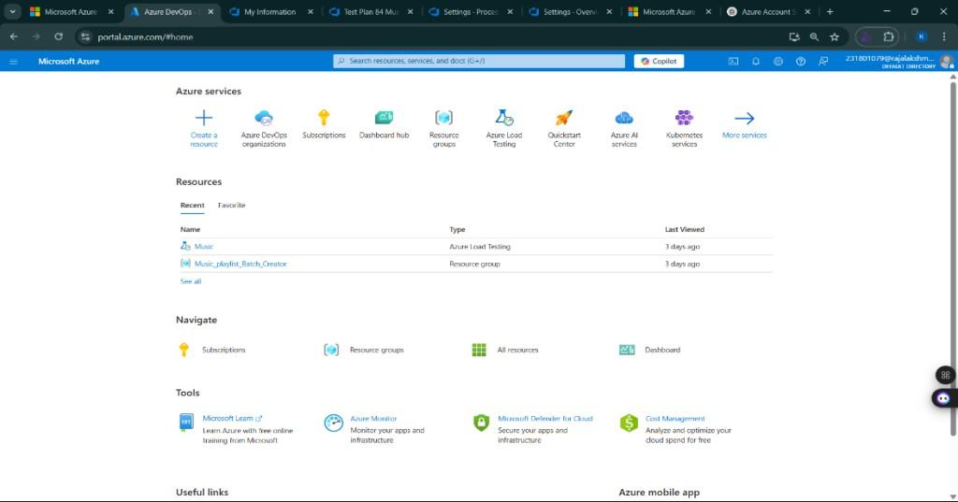

1. Open DevOps environment in the Azure platform by typing ***Azure DevOps Organizations*** in the search bar.

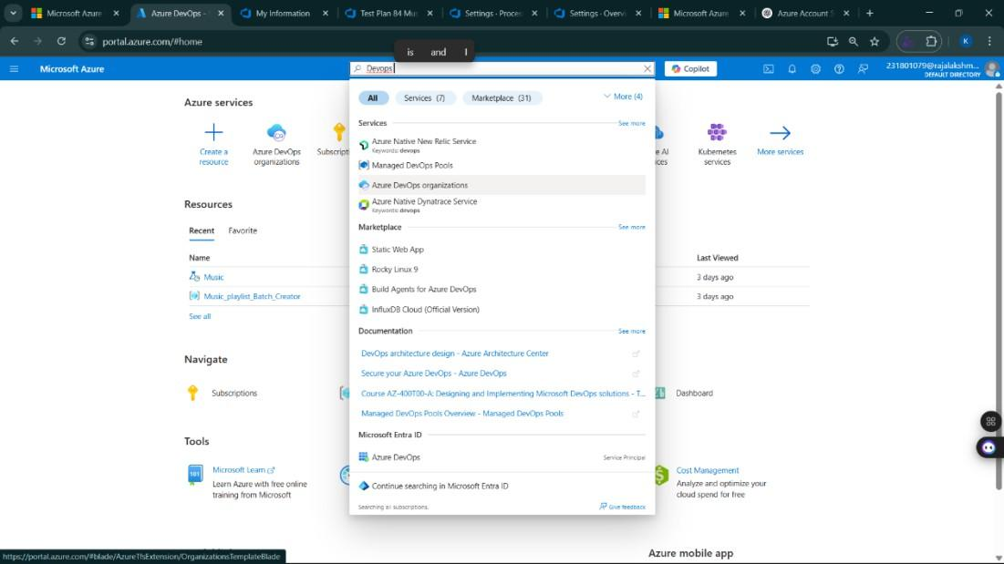

1. Click on the ***My Azure DevOps Organization*** link and create an organization and you should be taken to the Azure DevOps Organization Home page.

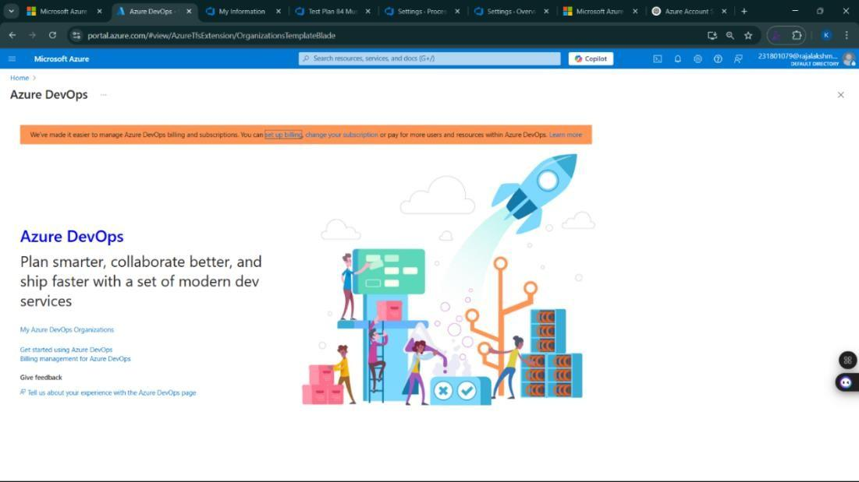

**Result:**

Successfully accessed the Azure DevOps environment and created a new organization through the Azure portal.



**Aim:**

To set up an Azure DevOps project for efficient collaboration and agile work management.

1. Create An Azure Account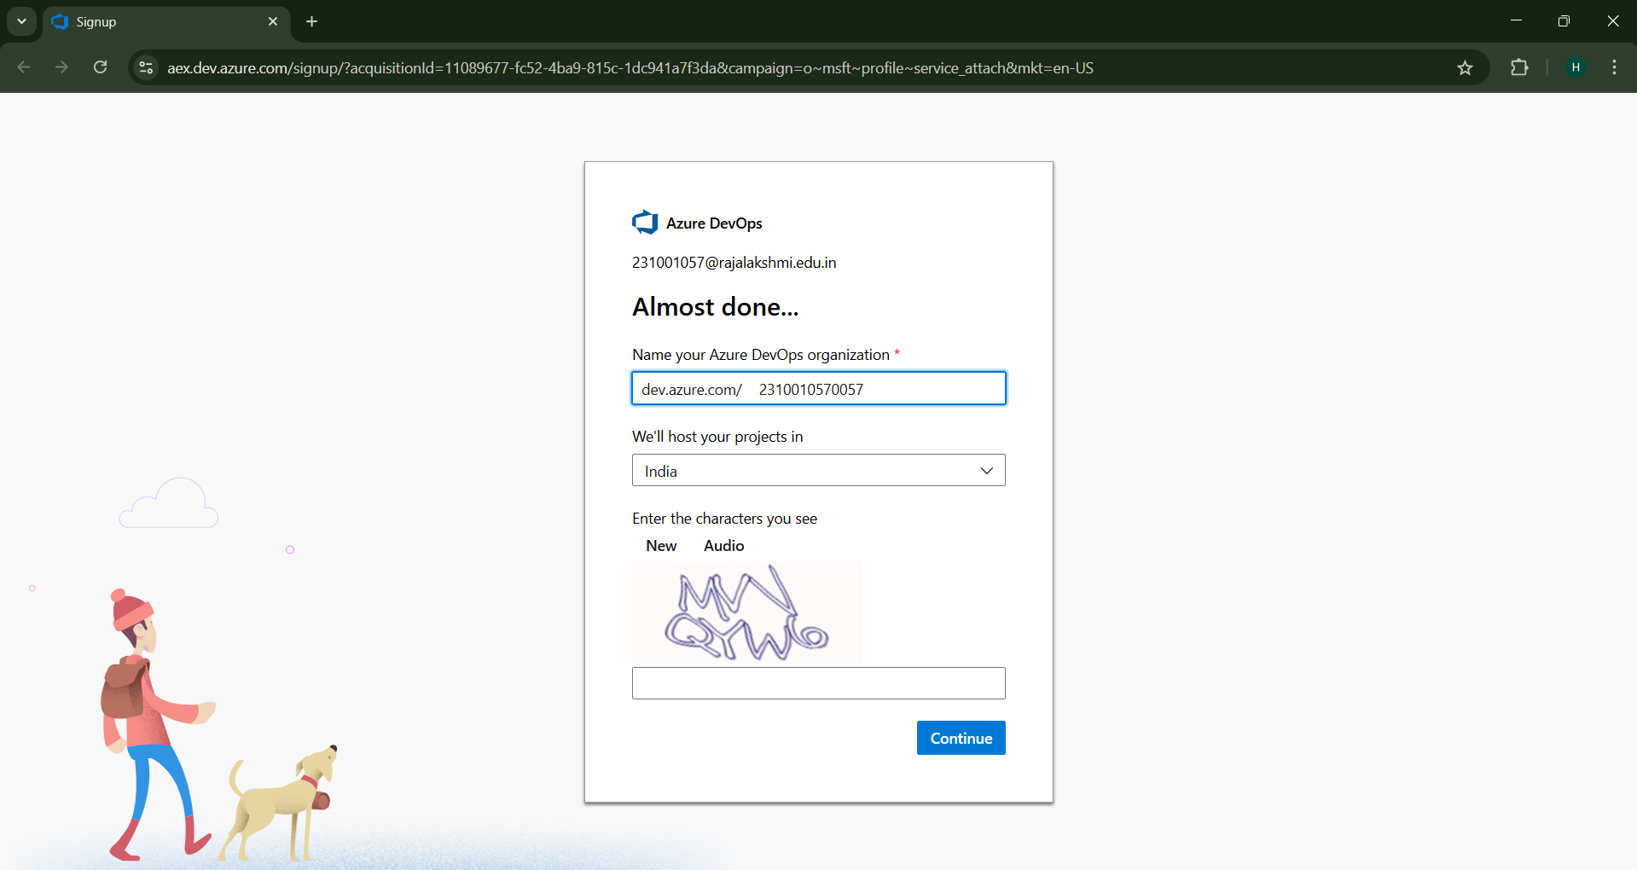
2. Create the First Project in Your Organization
   1. After the organization is set up, you’ll need to create your first **project**. This is where you'll begin to manage code, pipelines, work items, and more.
   2. On the organization’s **Home page**, click on the **New Project** button.
   3. Enter the project name, description, and visibility options:

***Name****:* Choose a name for the project (e.g., LMS).

***Description****:* Optionally, add a description to provide more context about the project. ***Visibility****:* Choose whether you want the project to be **Private** (accessible only to those invited) or **Public** (accessible to anyone).

* 1. Once you’ve filled out the details, click **Create** to set up your first project.

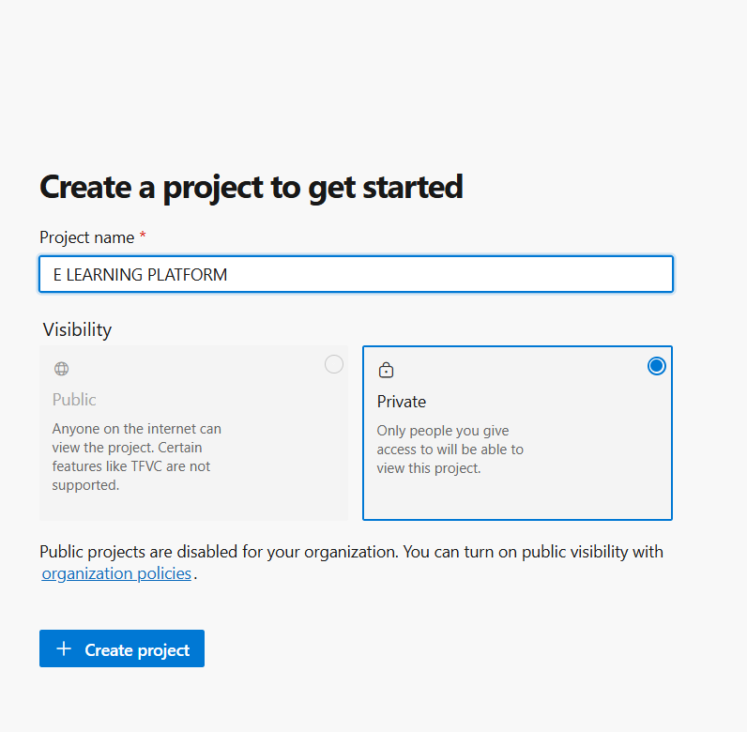

1. Once logged in, ensure you are in the correct organization. If you're part of multiple organizations, you can switch between them from the top left corner (next to your user profile). Click on the Organization name, and you should be taken to the Azure DevOps Organization Home page.

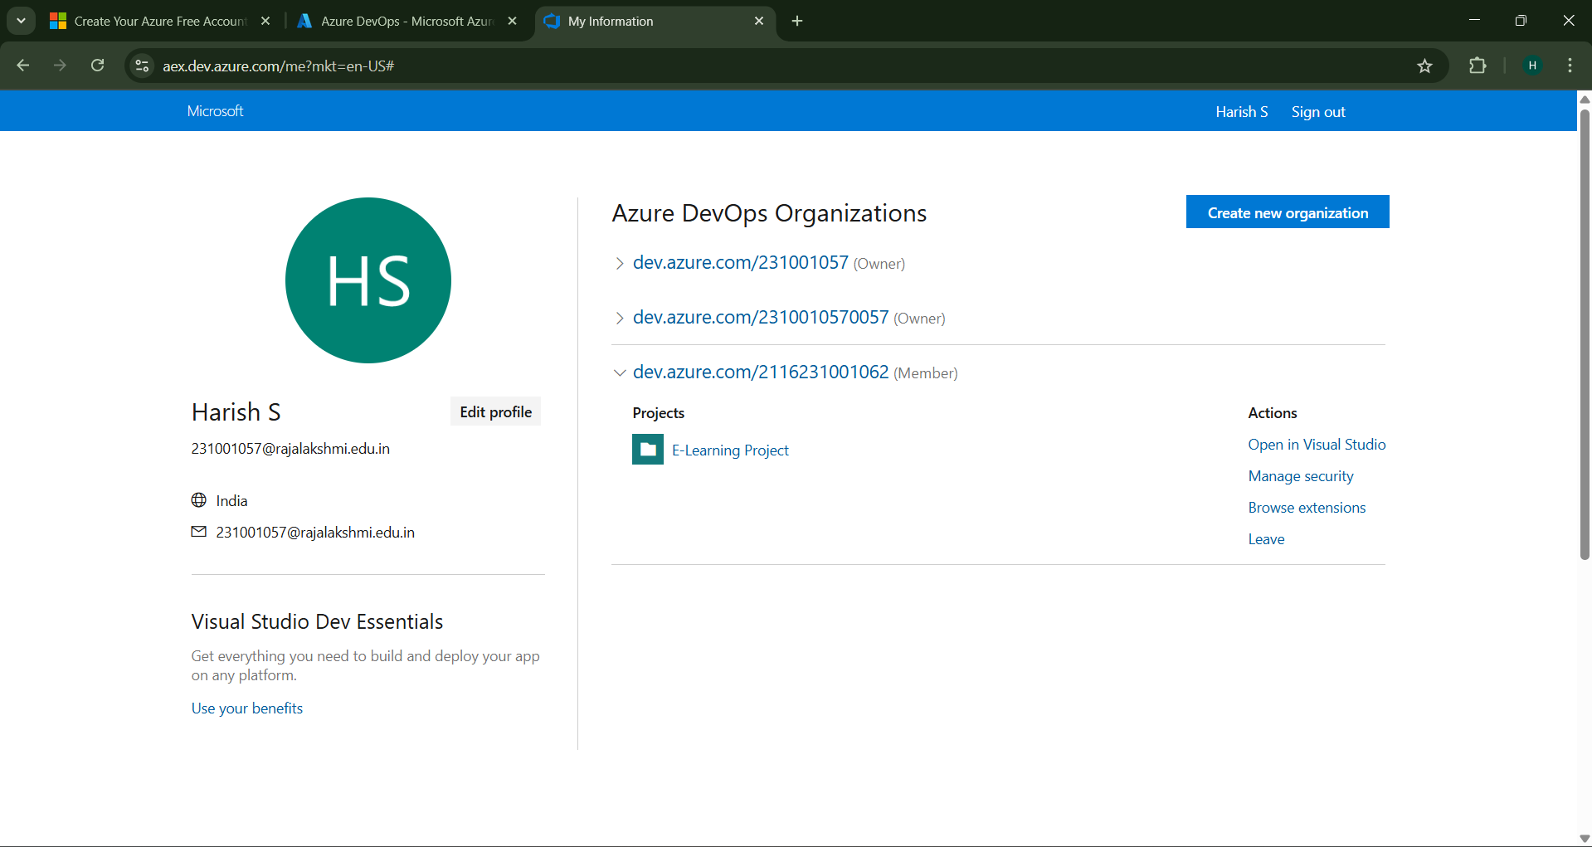

1. Project dashboard

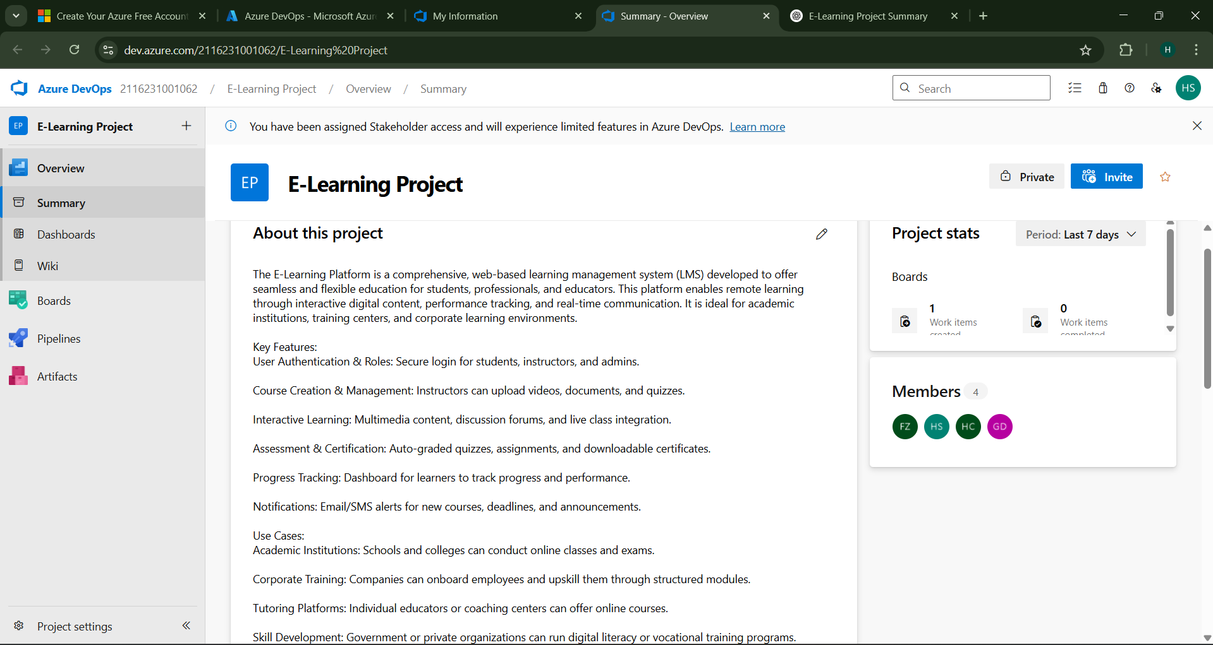

1. To manage user stories:
   1. From the **left-hand navigation menu**, click on **Boards**. This will take you to the main **Boards**

page, where you can manage work items, backlogs, and sprints.

* 1. On the **work items** page, you'll see the option to **Add a work item** at the top. Alternatively, you can find a **+** button or **Add New Work Item** depending on the view you're in. From the **Add a work item** dropdown, select **User Story**. This will open a form to enter details for the new User Story.

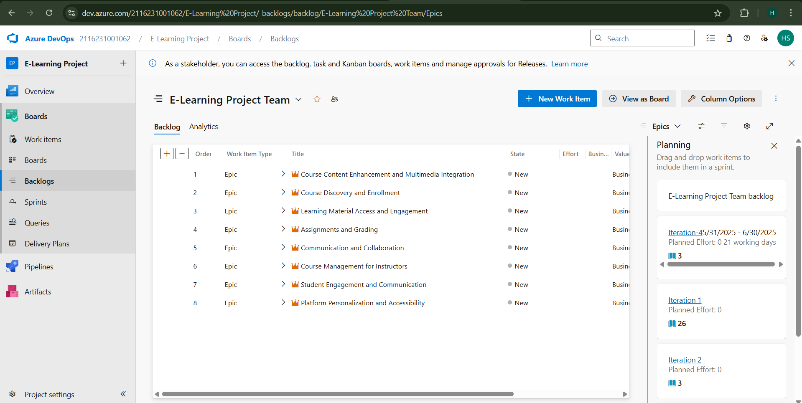

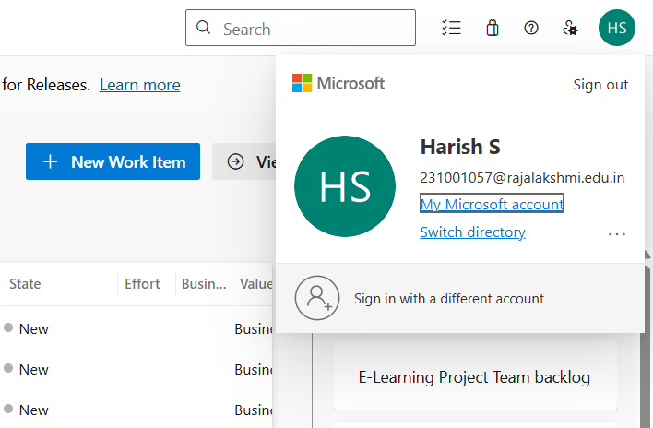

**Result:**

Successfully created an Azure DevOps project with user story management and an agile workflow setup.



**Aim:**

To learn about how to create epics, user story, features, backlogs for your assigned project.

**Create Epic, Features, User Stories, Task**

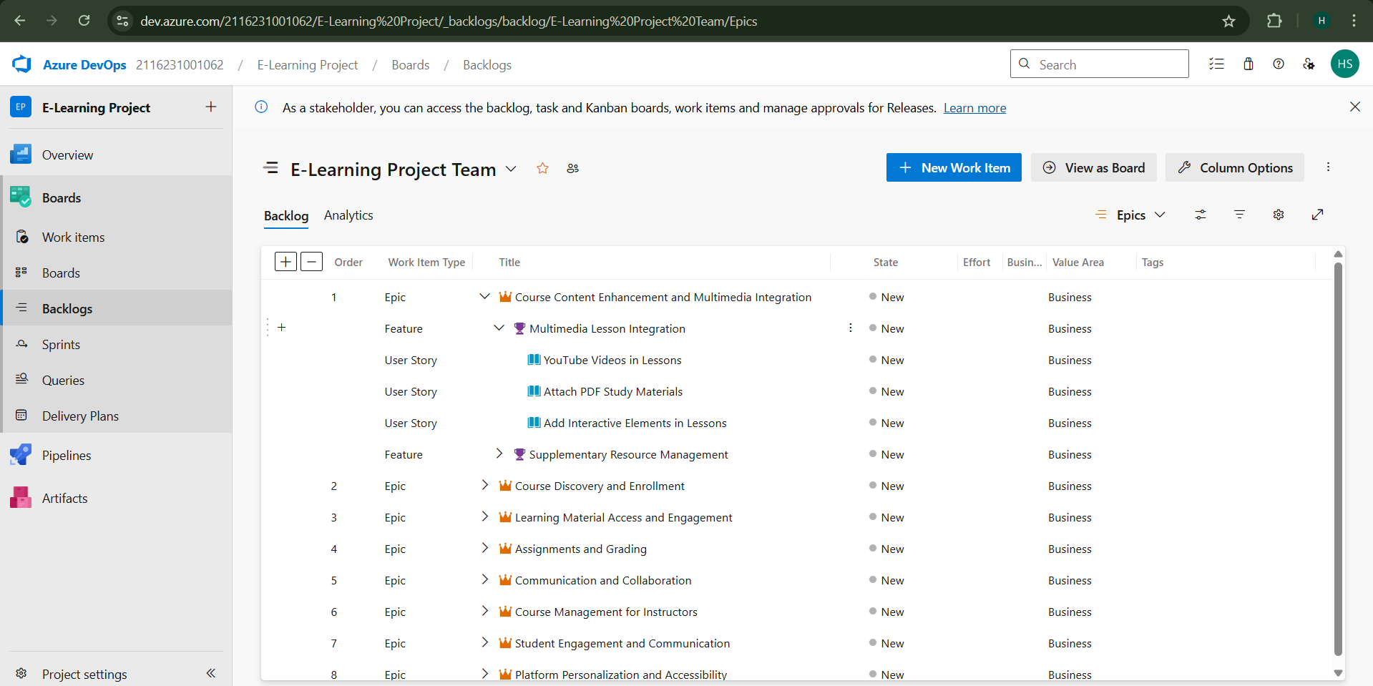

1. **Fill in Epics**

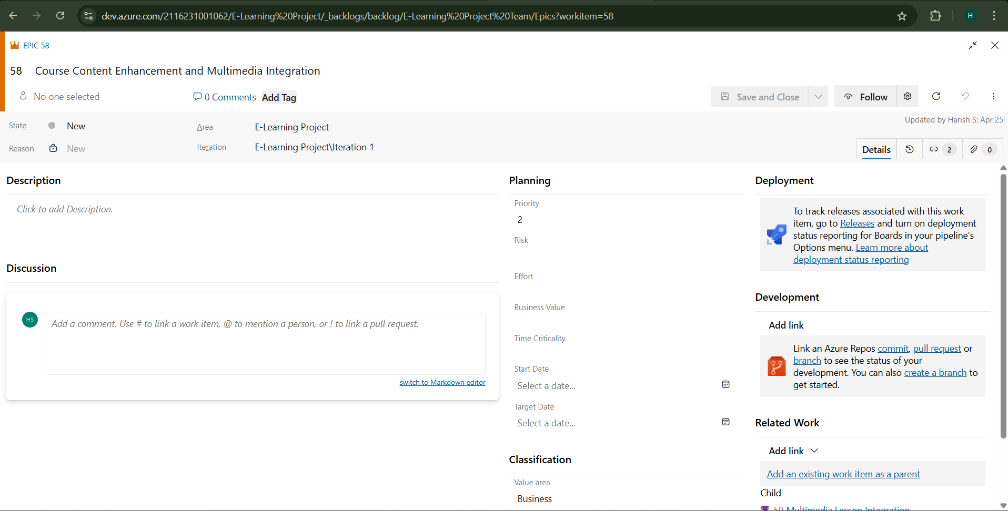

1. **Fill in Features**

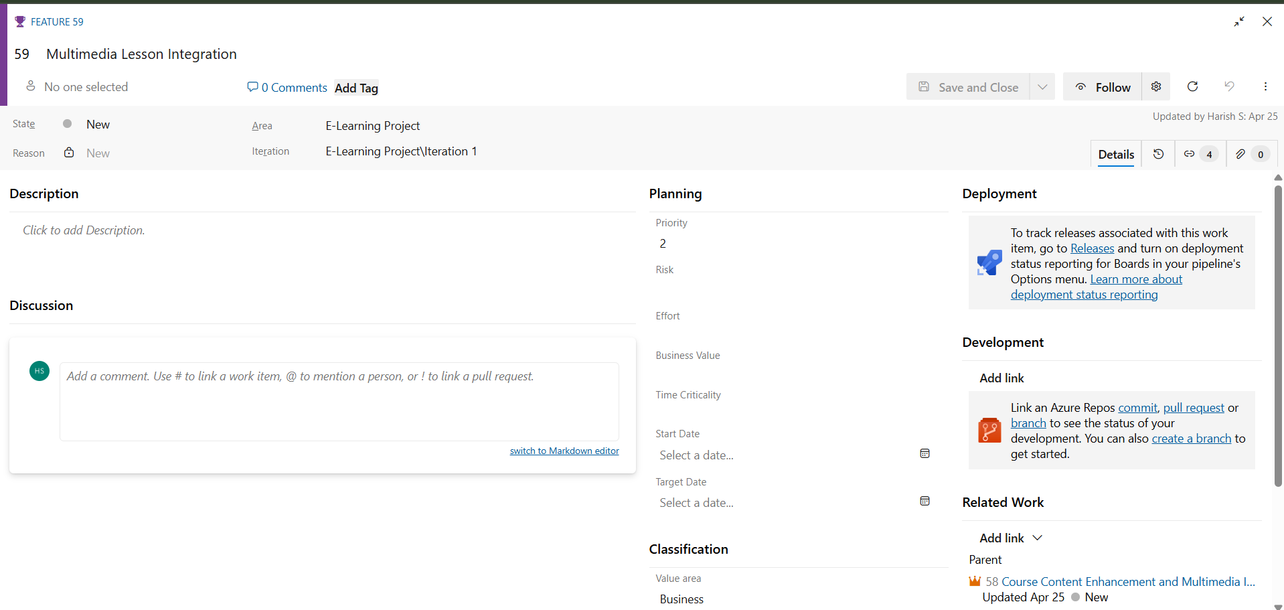

1. **Fill in User Story Details**

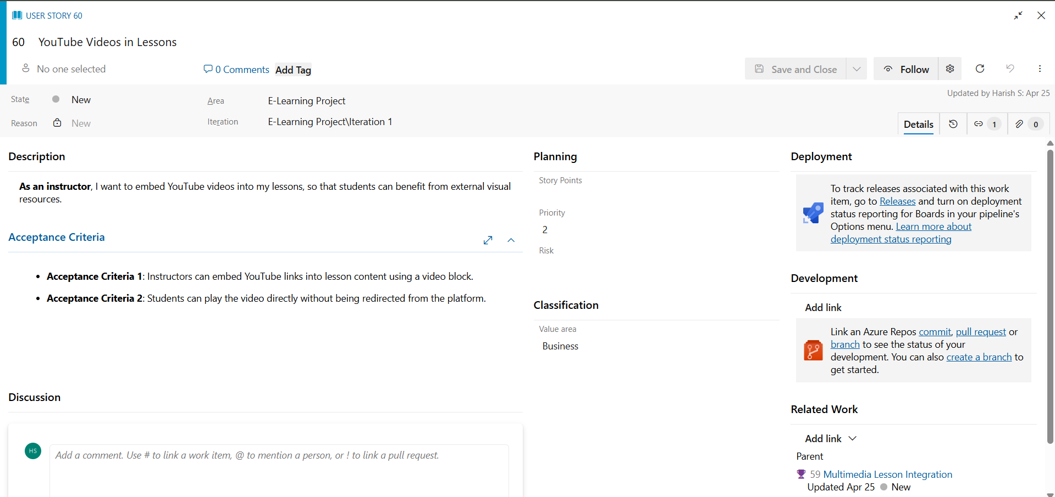

**Result:**

Thus, the creation of epics, features, user story and task has been created successfully.



**Aim:**

To assign user story to specific sprint for the Music Playlist Batch Creator Project.

**Sprint Planning Sprint 1**

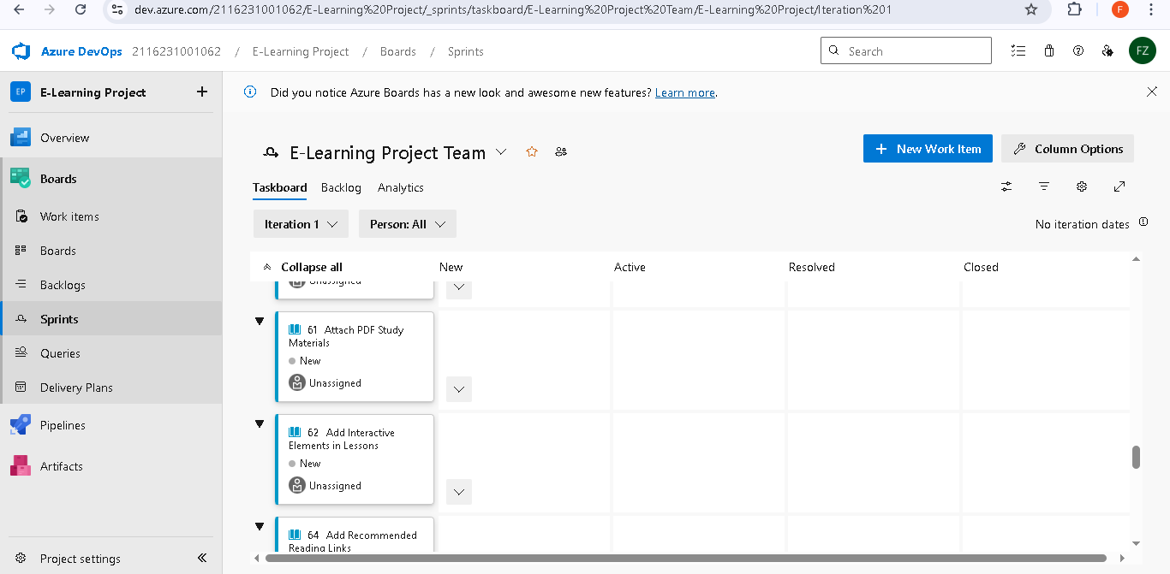

**Sprint-2**

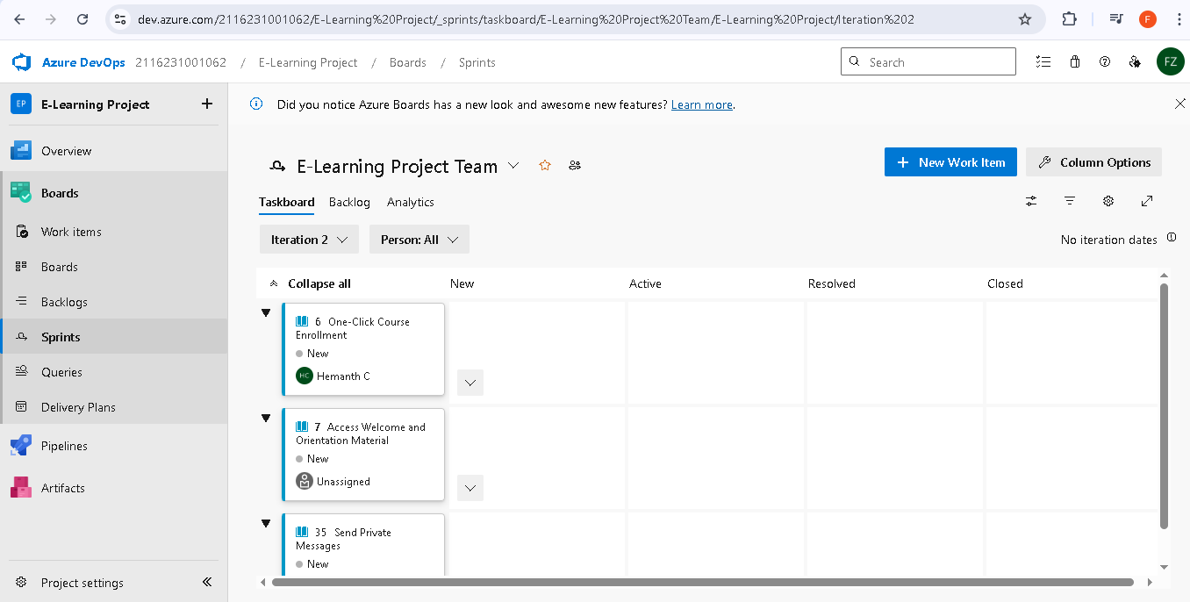

**Sprint 3**

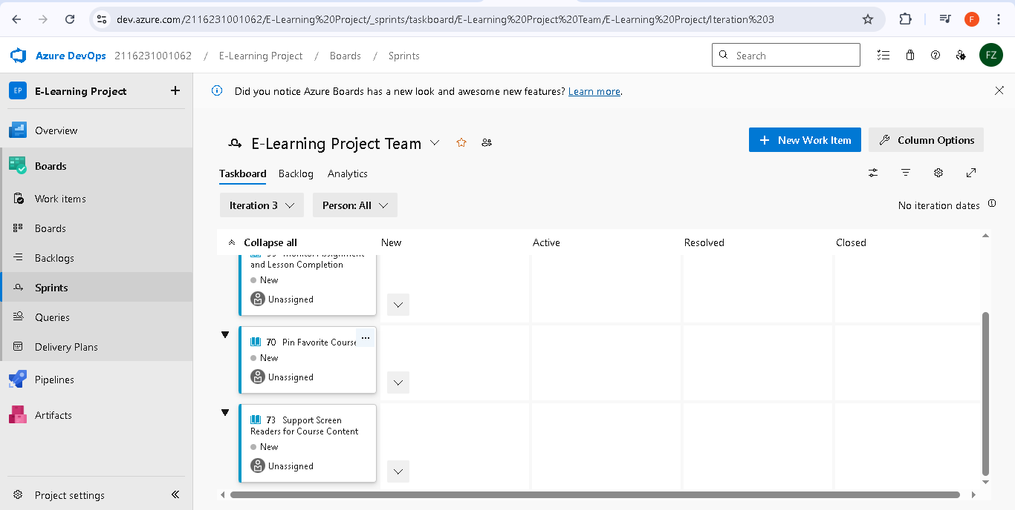

**Sprint 4**

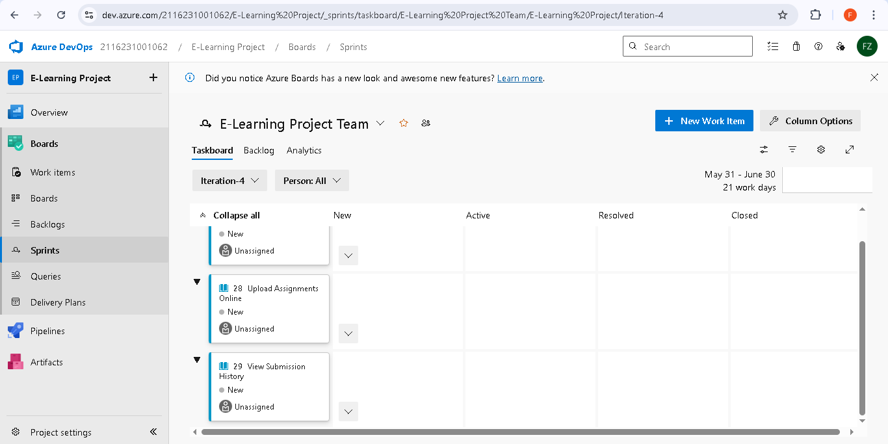

**Result:**

The Sprints are created for the E-Learning Project.



**Aim:**

Create Poker Estimation for the user stories - E-Learning Project.

**Poker Estimation**

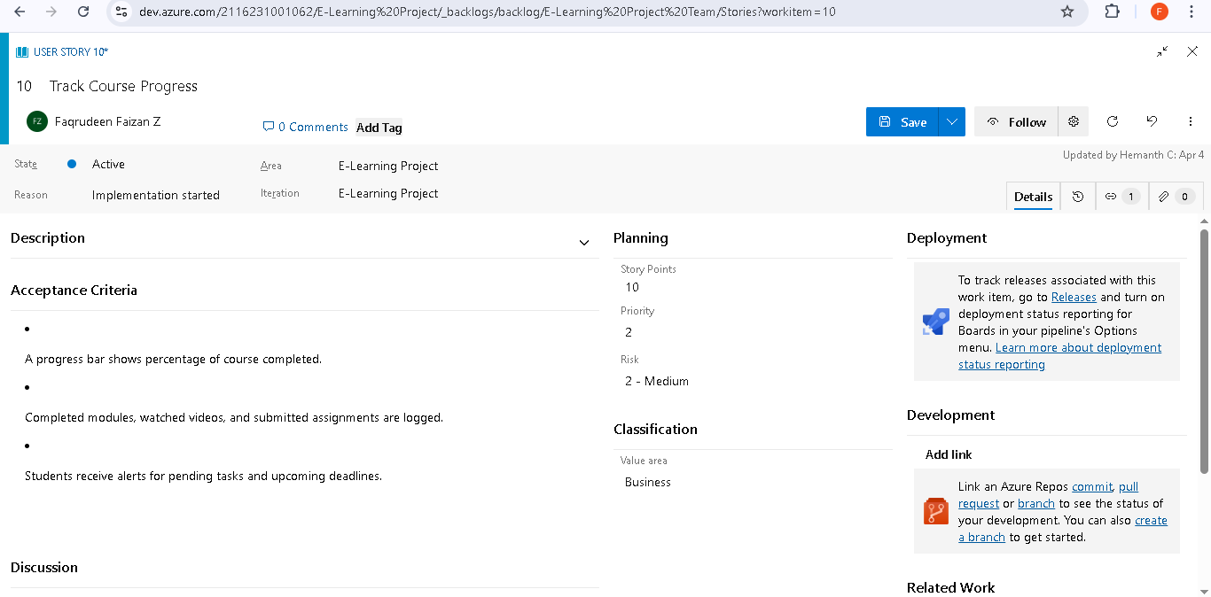

**Result:**

The Estimation/Story Points is created for the project using Poker Estimation.



**Aim:**

To Design a Class Diagram and Sequence Diagram for the given Project.

**6A. Class Diagram**

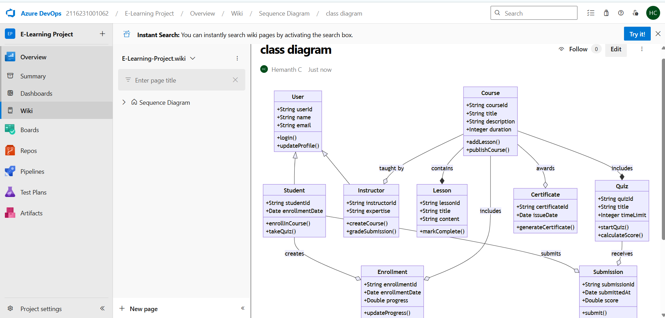

**6B. Sequence Diagram**

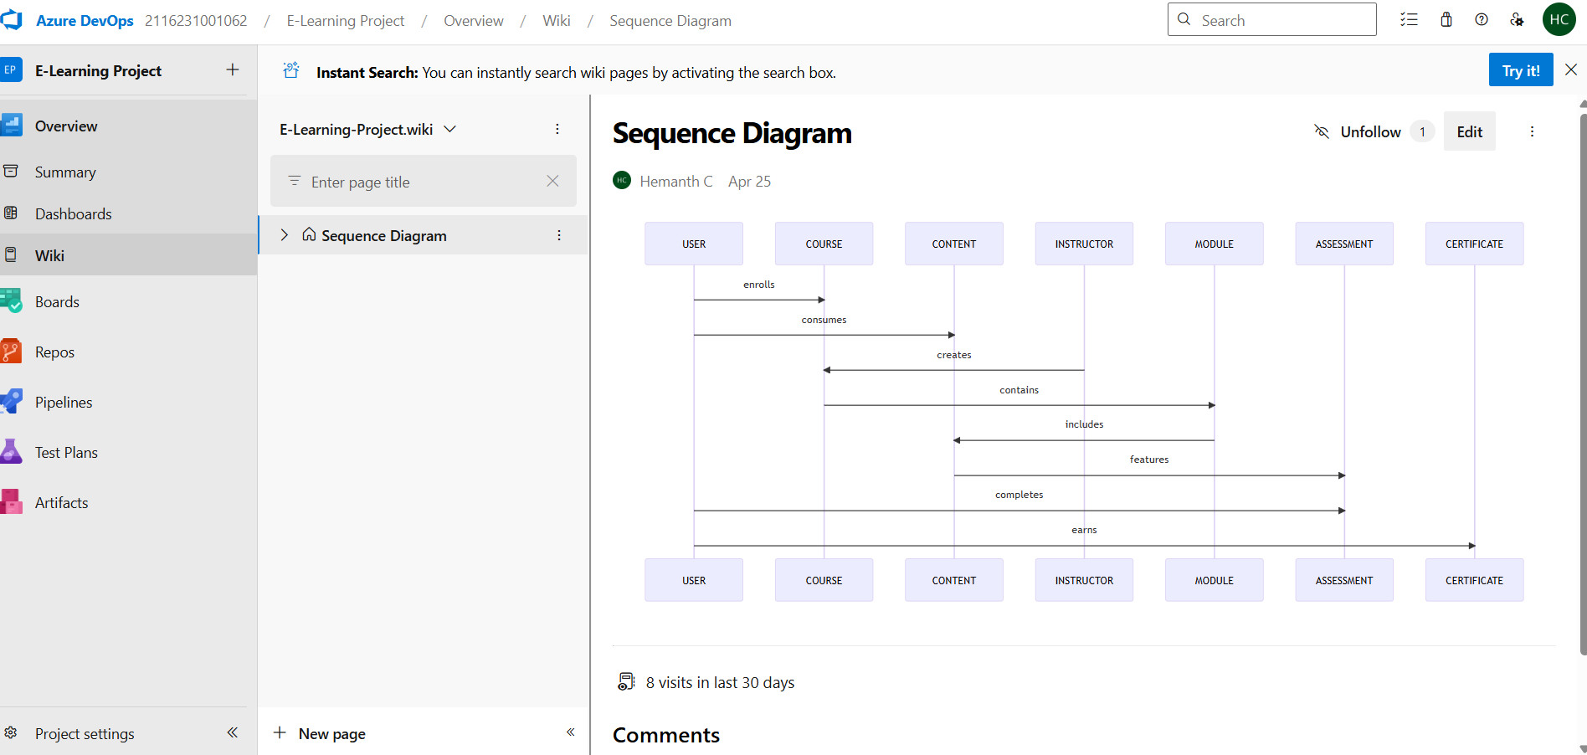

**Result:**

The Class Diagram and Sequence Diagram is designed Successfully for the E-learning platform project.



**Aim:**

To Design an Architectural Diagram and ER Diagram for the given Project.

**7A. Architectural Diagram**

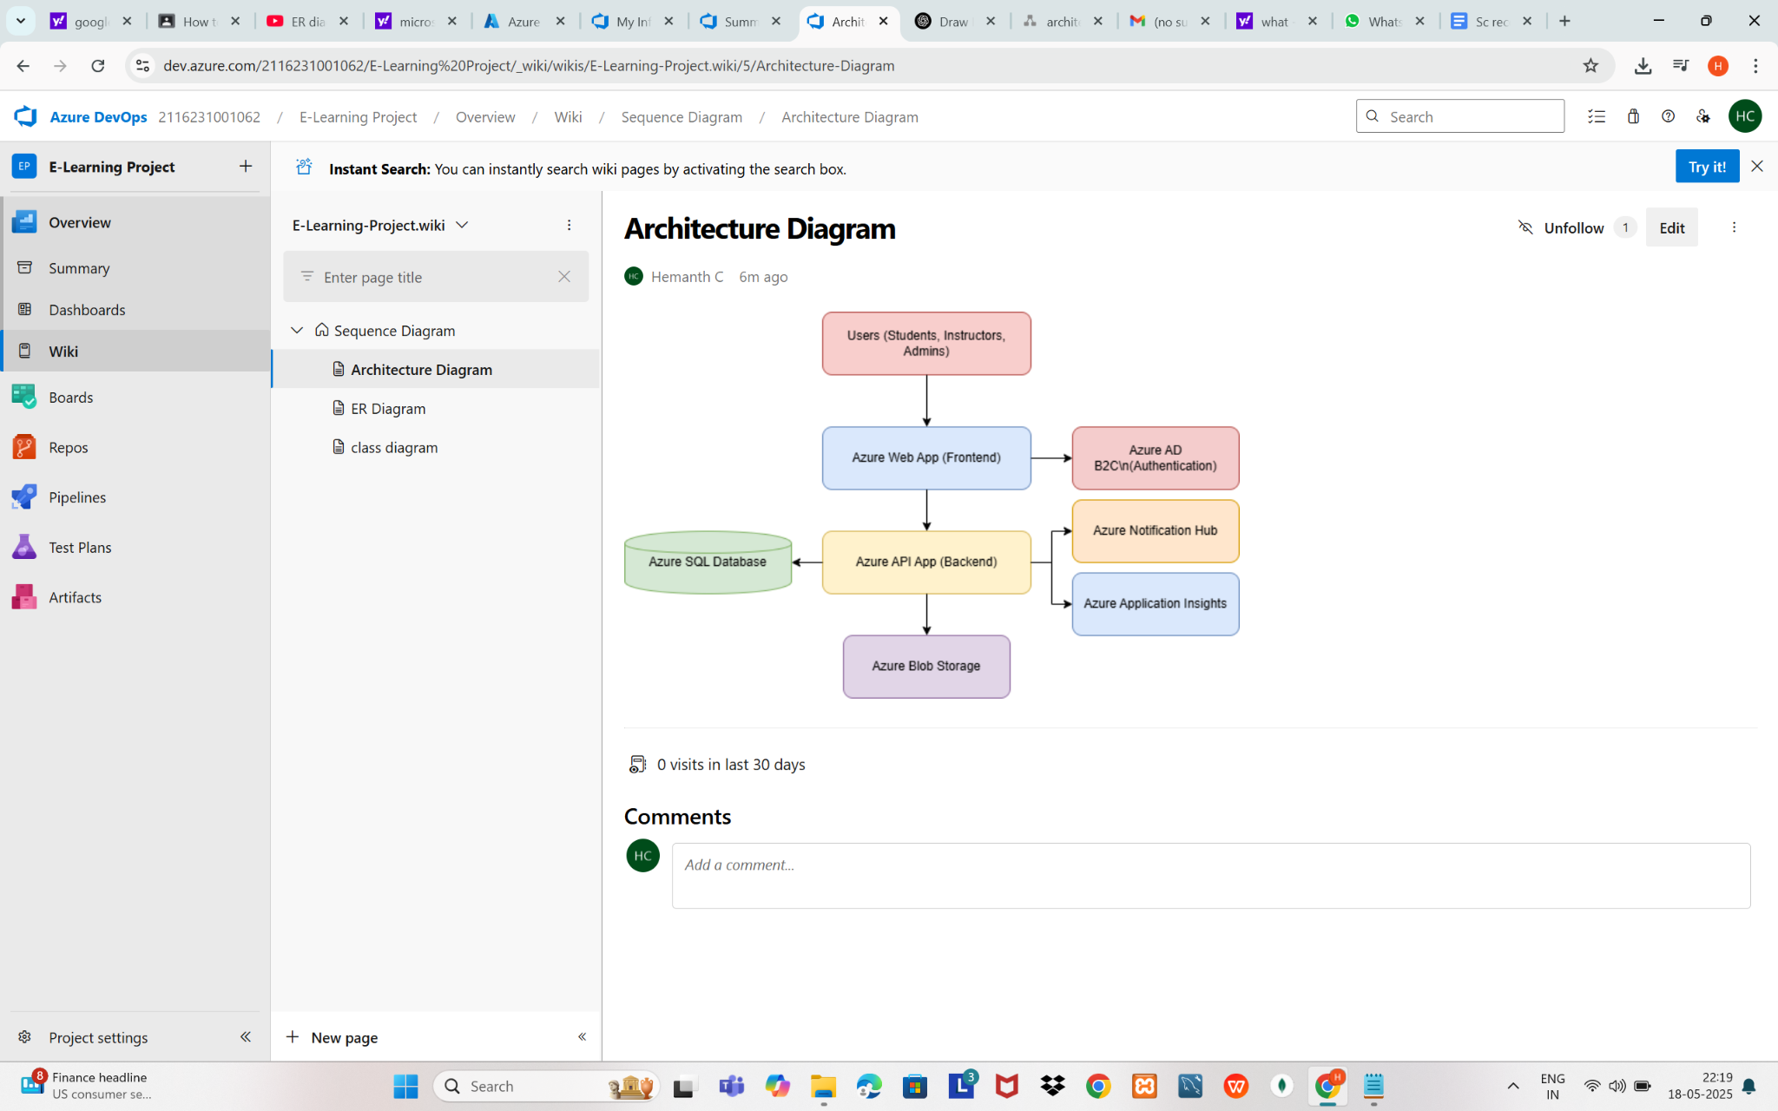

**7B.ER Diagram**

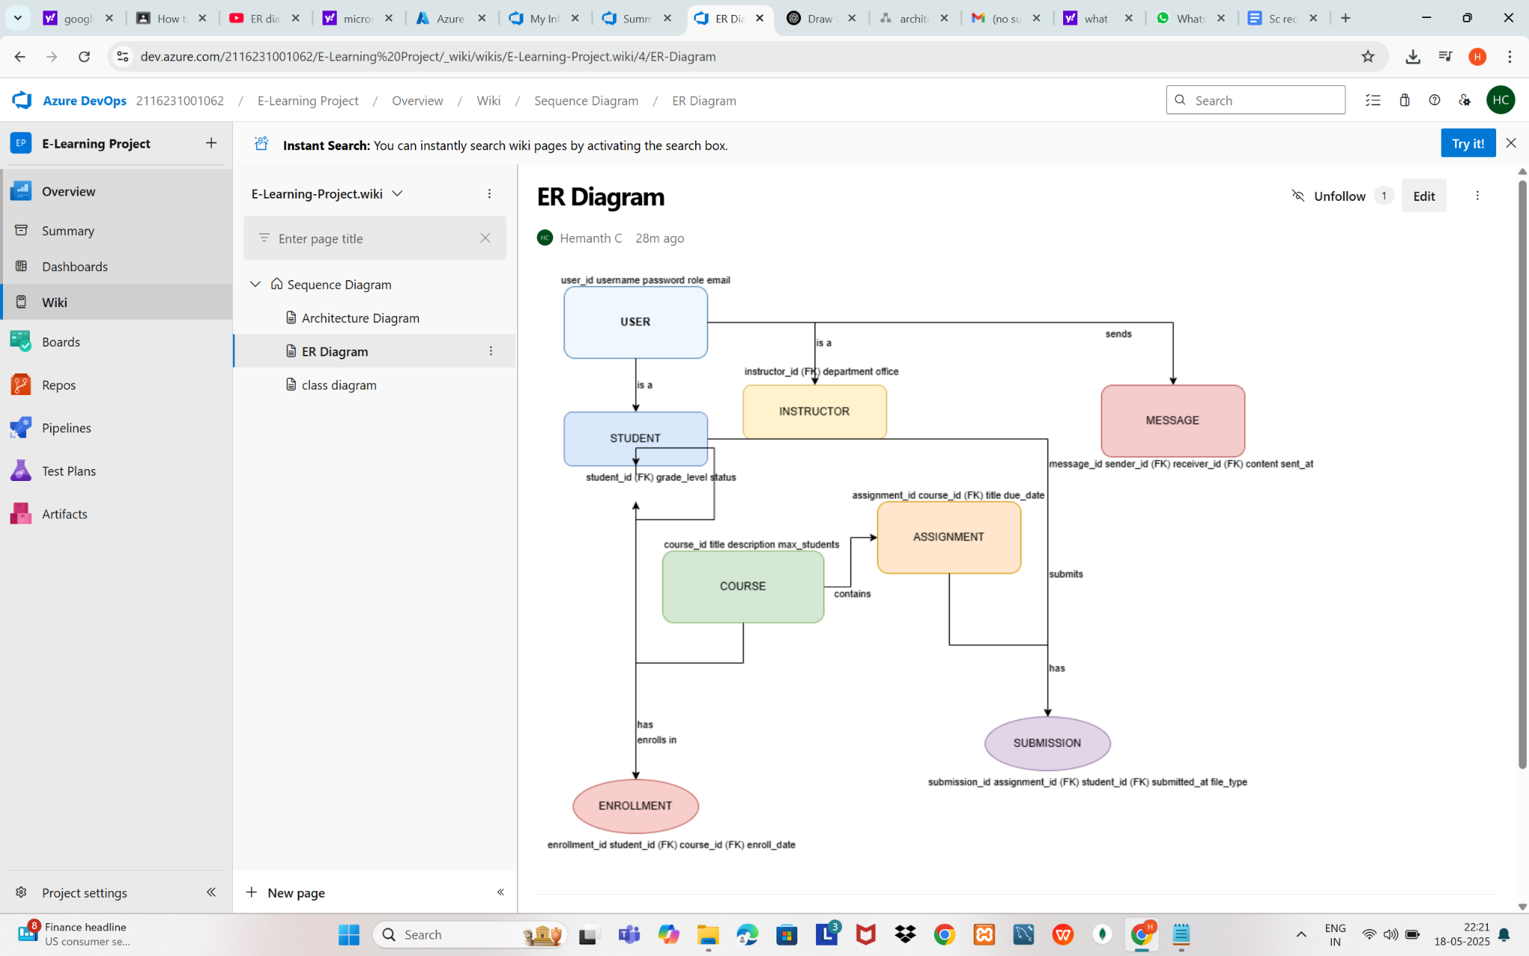

**Result** :

The Architecture Diagram and ER Diagram is designed successfully for E-Learning platform project.



**Aim:**

Test Plans and Test Case and write two test cases for at least five user stories showcasing the

happy path and error scenarios in azure DevOps platform.

**Test Planning and Test Case Test Case Design Procedure**

1. **Understand Core Features of the Application**
   * User Signup & Login
   * Viewing and Managing course
   * Fetching Real-time Metadata
   * Editing course (rename, reorder, record)
   * Creating smart course playlists based on categories
2. **Define User Interactions**
   * Each test case simulates a real user behaviour (e.g., logging in , adding a course).
3. **Design Happy Path Test Cases**
   * Focused on validating that all features function as expected under normal conditions.
   * Example: User logs in successfully, adds item , or creates a category-based .
4. **Design Error Path Test Cases**
   * Simulate negative or unexpected scenarios to test robustness and error handling.
   * Example: Login fails with invalid credentials, save fails when offline, no recommendations found.
5. **Break Down Steps and Expected Results**
   * Each test case contains step-by-step actions and a corresponding expected outcome.
   * Ensures clarity for both testers and automation scripts.
6. **Use Clear Naming and IDs**
   * Test cases are named clearly (e.g., TC01 – Successful Login, TC10 – Save Fails).
   * Helps in quick identification and linking to user stories or features.
7. **Separate Test Suites**
   * Grouped test cases based on functionality (e.g., Login, Editing, Recommendation System).
   * Improves organization and test execution flow in Azure DevOps.
8. **Prioritize and Review**
   * Critical user actions are marked high-priority.
   * Reviewed for completeness and traceability against feature requirements.
9. **New test plan**

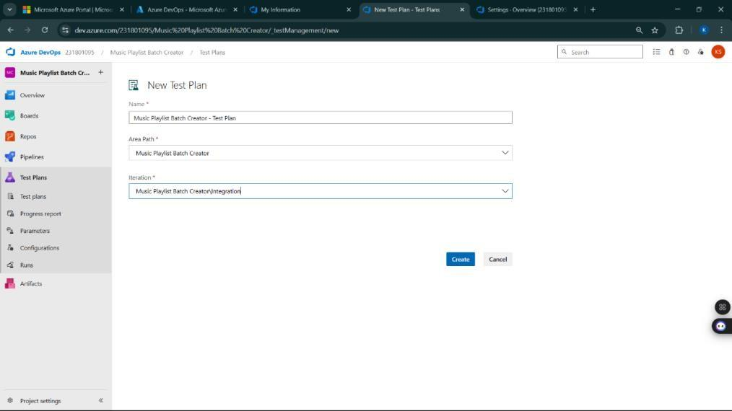

1. **Test suite**

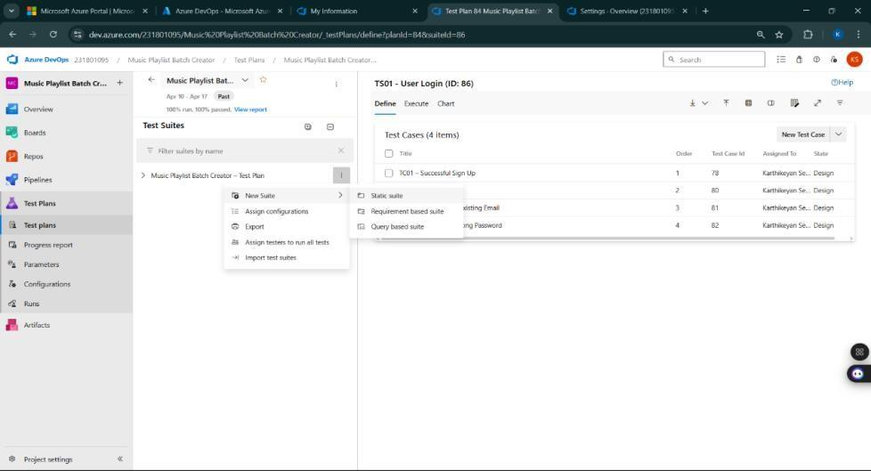

1. **Test case**

TC01 – Successful Sign Up

**Action:**

* Go to the Sign-Up page.
* Enter a valid name, email, and password.
* Click "Sign Up".

**Expected Results:**

* Form is displayed properly.
* Fields accept valid input.
* Account is created, and the user is redirected to the dashboard.

**Type:** Happy Path

### TC02 – Sign Up with Existing Email

**Action:**

* Go to the Sign-Up page.
* Enter a name and an already registered email.
* Click "Sign Up".

**Expected Results:**

* Fields accept input.
* Error message "Email already registered" is shown.

**Type:** Error Path

## Test Suite: TS02 - Course Dashboard (ID: 202)

### TC03 – View Enrolled Courses

**Action:**

* Login successfully.
* Navigate to "My Courses".

**Expected Results:**

* All enrolled courses are listed with thumbnails and progress indicators.

**Type:** Happy Path

### TC04 – Courses Not Loading

**Action:**

* Disconnect internet.
* Navigate to "My Courses".

**Expected Results:**

* Page loads with placeholder.
* Error message "Unable to load courses. Please check your connection." is shown.

**Type:** Error Path

## Test Suite: TS03 - Course Enrollment (ID: 203)

### TC05 – Successful Course Enrollment

**Action:**

* Login successfully.
* Navigate to "Course Catalog".
* Select a course and click "Enroll".

**Expected Results:**

* Course is added to "My Courses" list.
* Confirmation message "Successfully enrolled" is shown.

**Type:** Happy Path

### TC06 – Enrollment Failure Due to Server Issue

**Action:**

* Login successfully.
* Select a course and click "Enroll".
* Simulate backend server error.

**Expected Results:**

* Enrollment fails.
* Error message: "Unable to enroll at this moment. Try again later."

**Type:** Error Path

## Test Suite: TS04 - Quiz System (ID: 204)

### TC07 – Take and Submit Quiz Successfully

**Action:**

* Navigate to an enrolled course.
* Click on "Start Quiz".
* Answer all questions.
* Click "Submit".

**Expected Results:**

* Quiz is submitted.
* Immediate feedback and score are displayed.

**Type:** Happy Path

### TC08 – Quiz Submission Timeout

**Action:**

* Start a quiz.
* Wait until the session times out without submitting.

**Expected Results:**

* Quiz auto-submits.
* Message: "Session expired. Auto-submitted."
* Partial feedback shown if applicable.

**Type:** Error Path

## Test Suite: TS05 - Progress Tracking (ID: 205)

### TC09 – Real-Time Progress Updates

**Action:**

* Start watching a lesson video.
* Mark lesson as completed.

**Expected Results:**

* Progress bar updates instantly.
* Course dashboard reflects updated status.

**Type:** Happy Path

### 

### 

### TC10 – Progress Not Updating Due to Session Expiry

**Action:**

* Start a lesson.
* Stay idle until session expires.
* Try to mark lesson as completed.

**Expected Results:**

* Action fails.
* Message: "Session expired. Please log in again to continue."

**Type:** Error Path

**Test Cases**

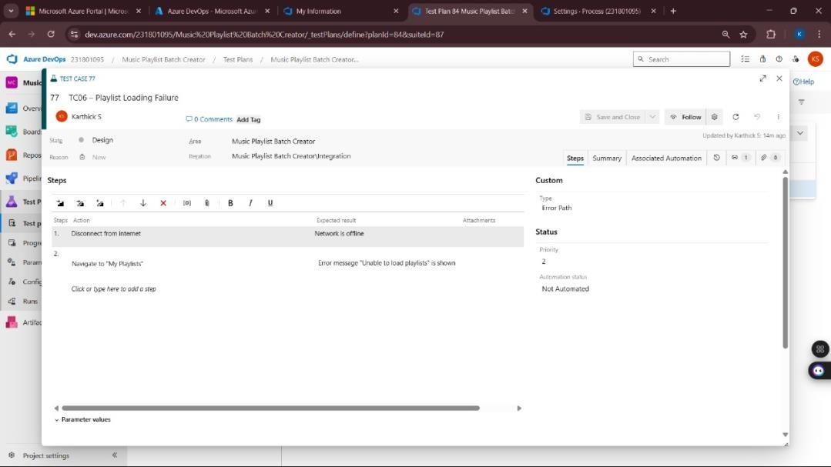

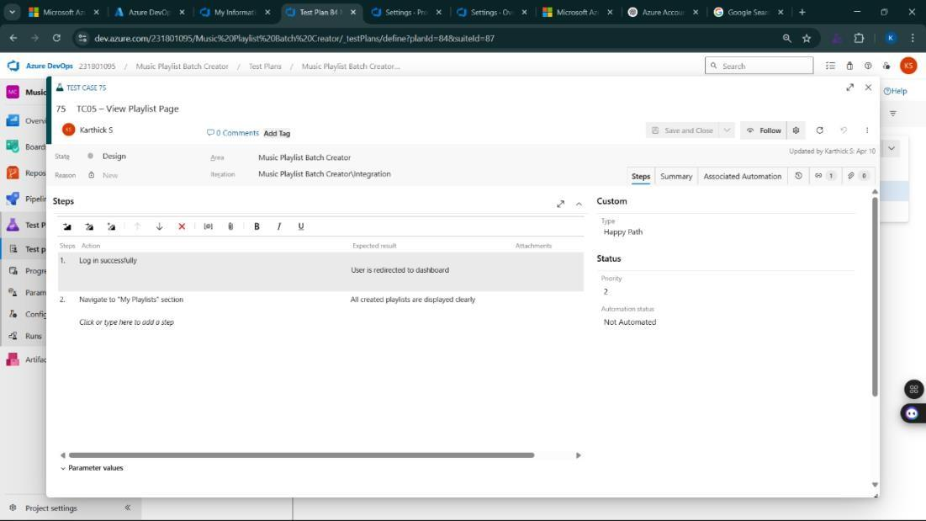

1. **Installation of test**

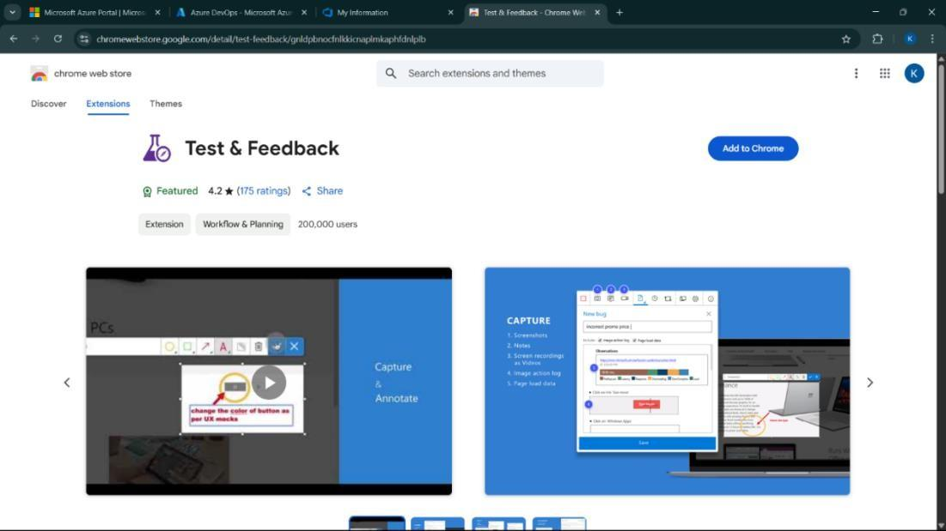

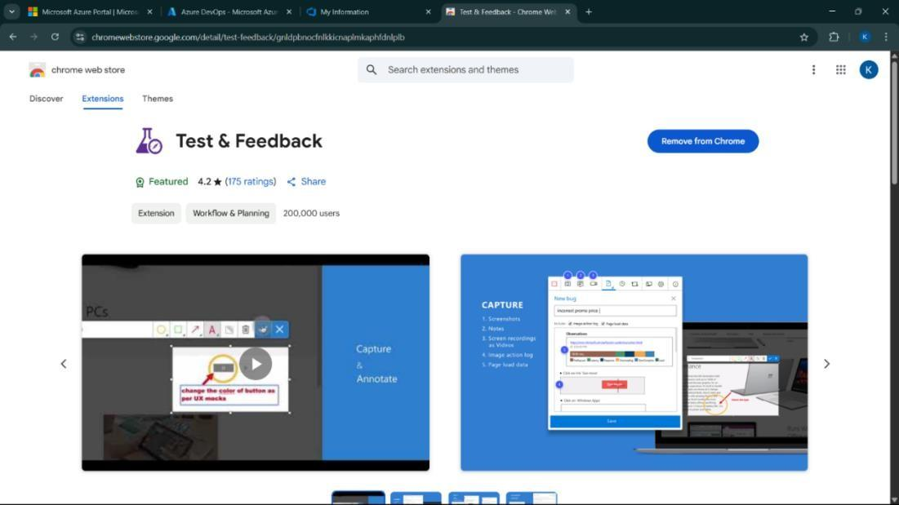

Test and feedback Showing it as an extension

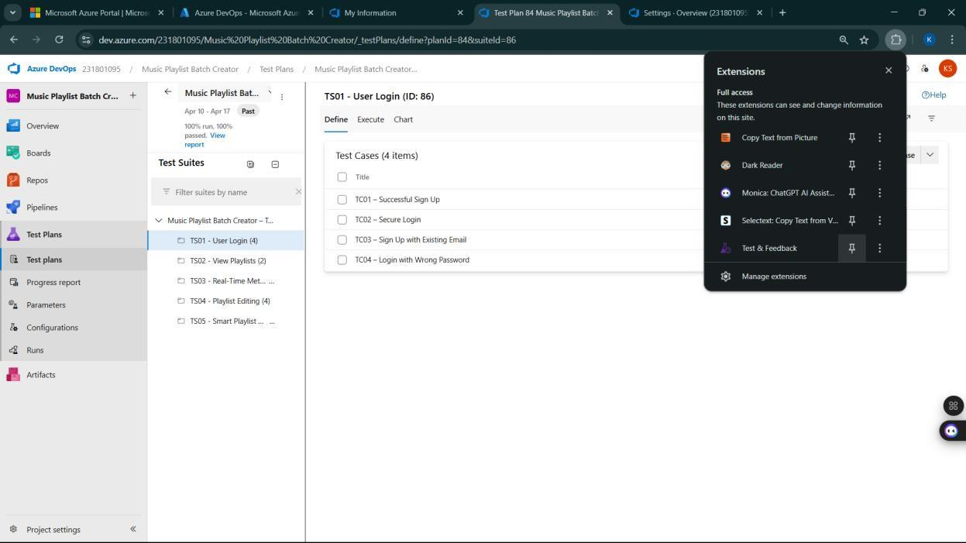

1. **Running the test cases**

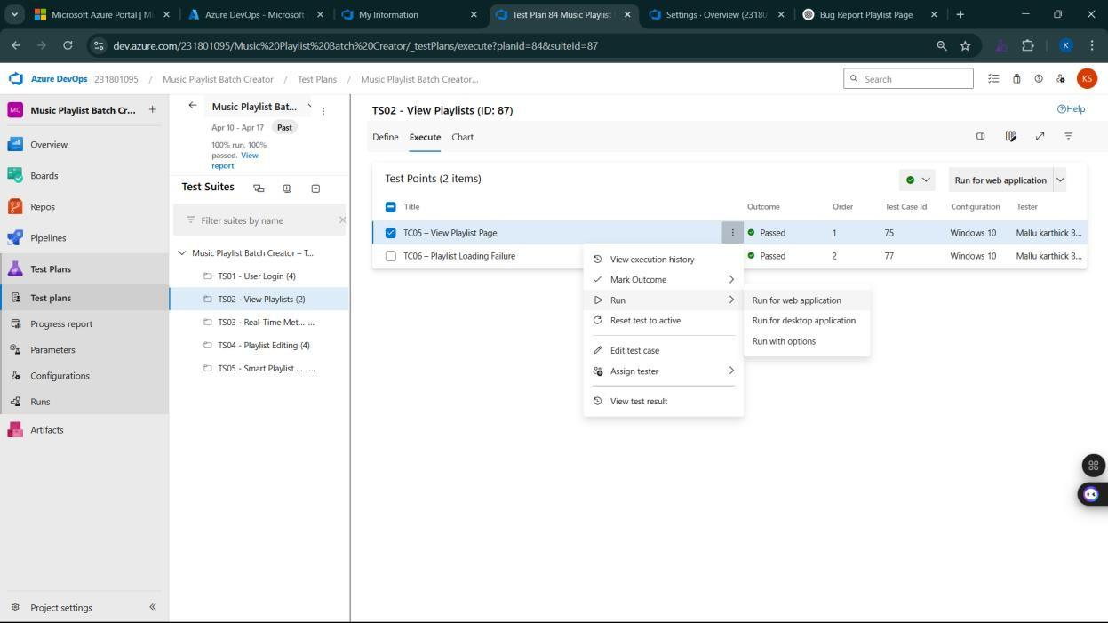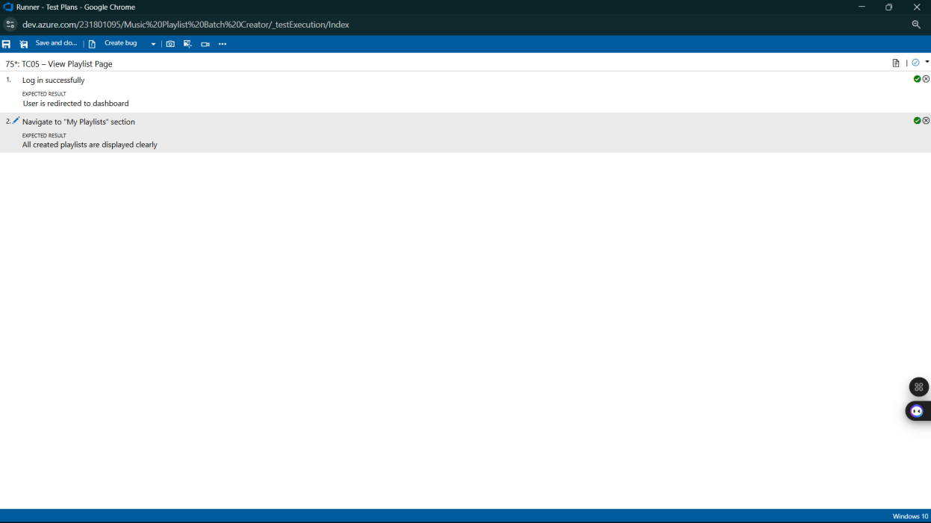

1. **Recording the test case**

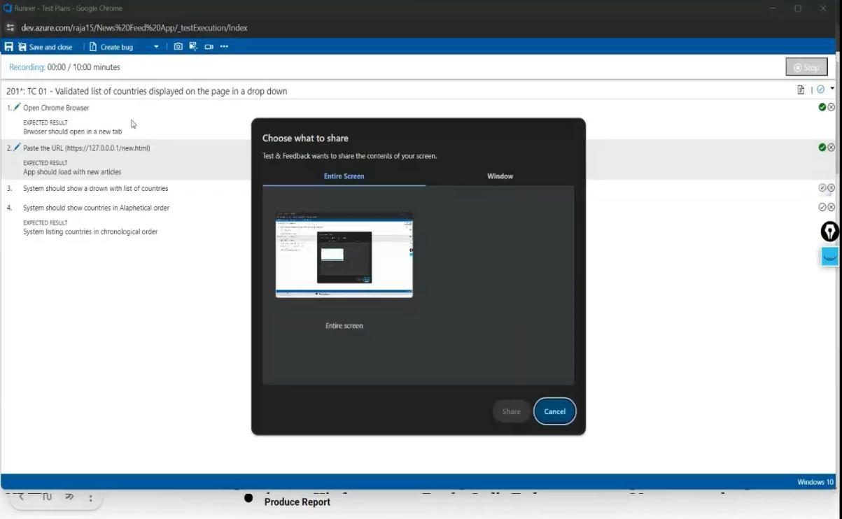

1. **Creating the bug**

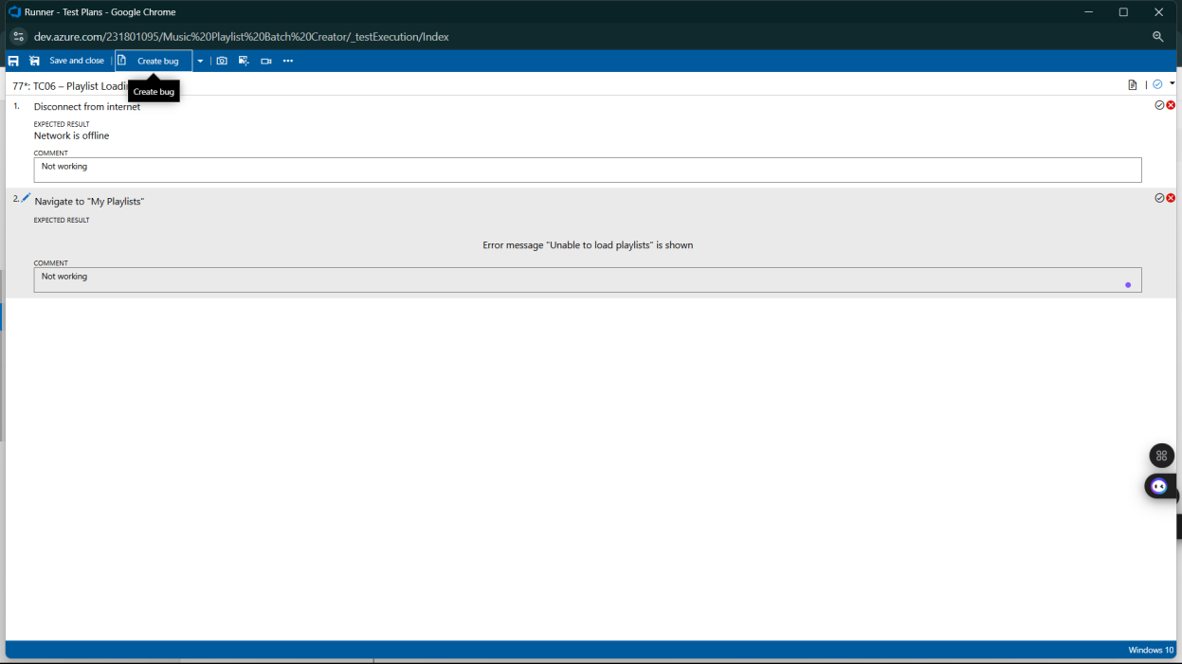

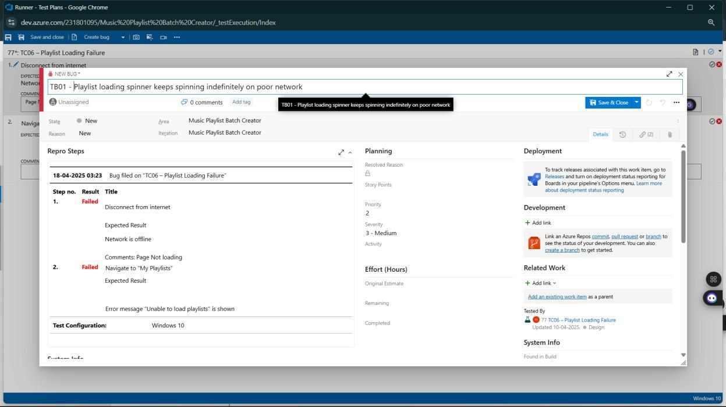

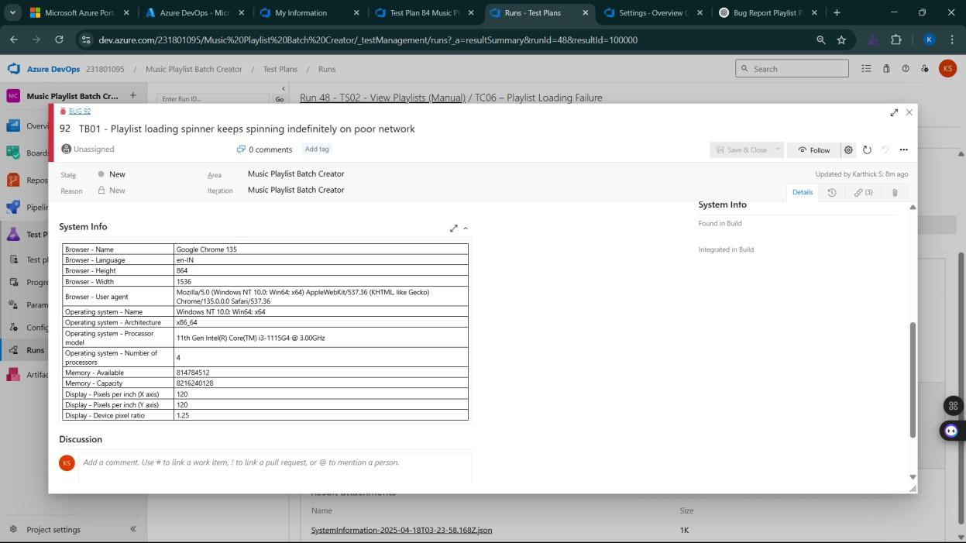

1. **Test case results**

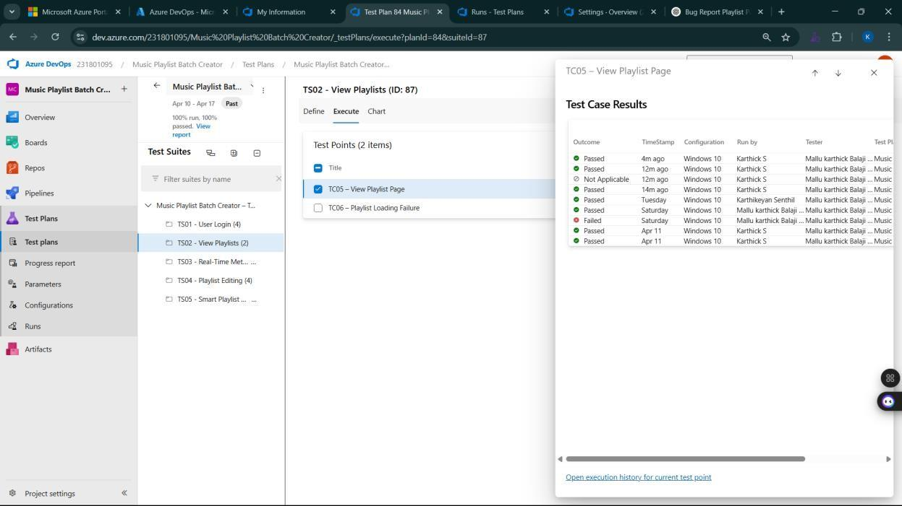

1. **Test report summary**
   * Assigning bug to the developer and changing state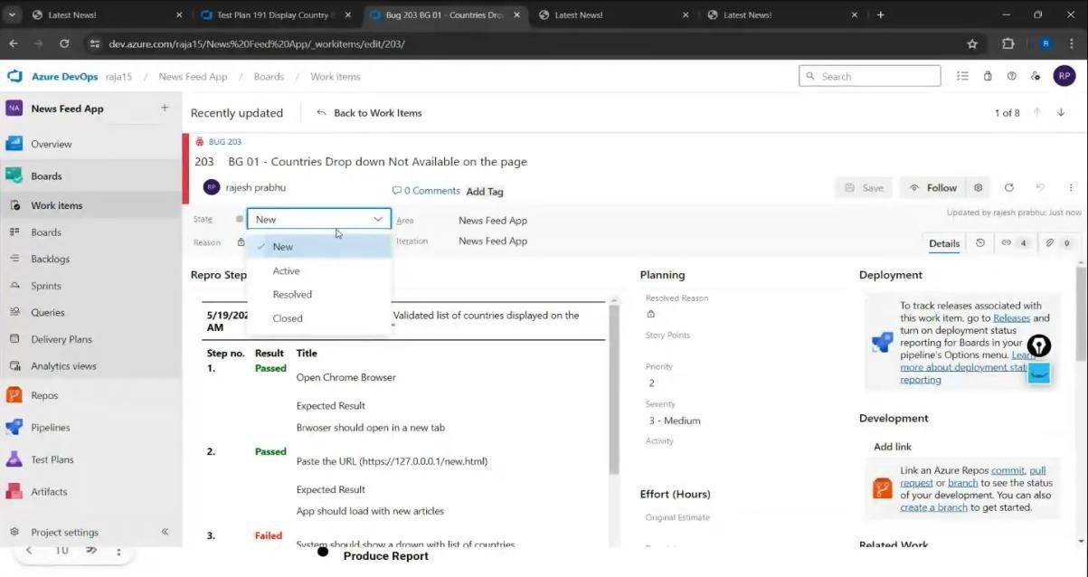

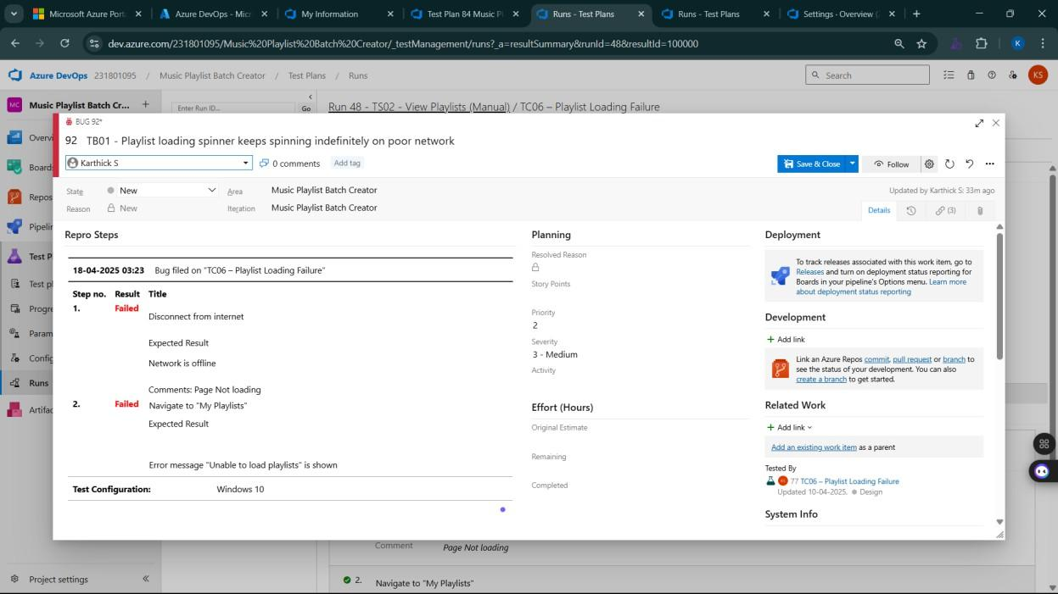

1. **Progress report**

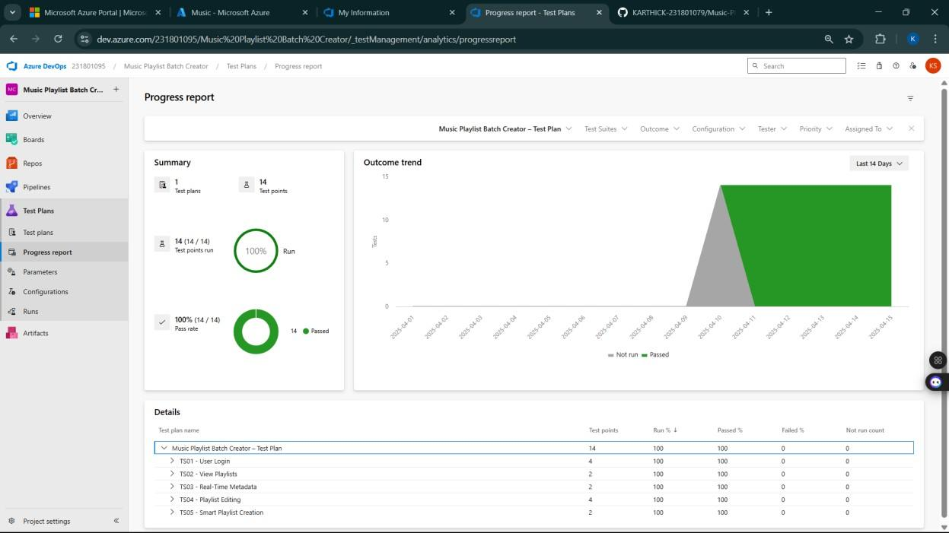

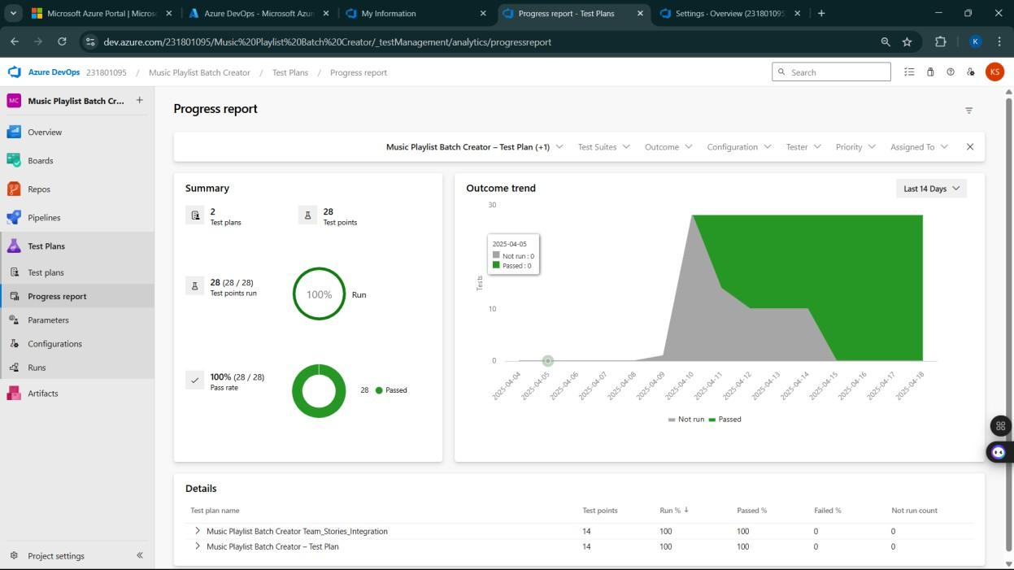

1. **Changing the test template**

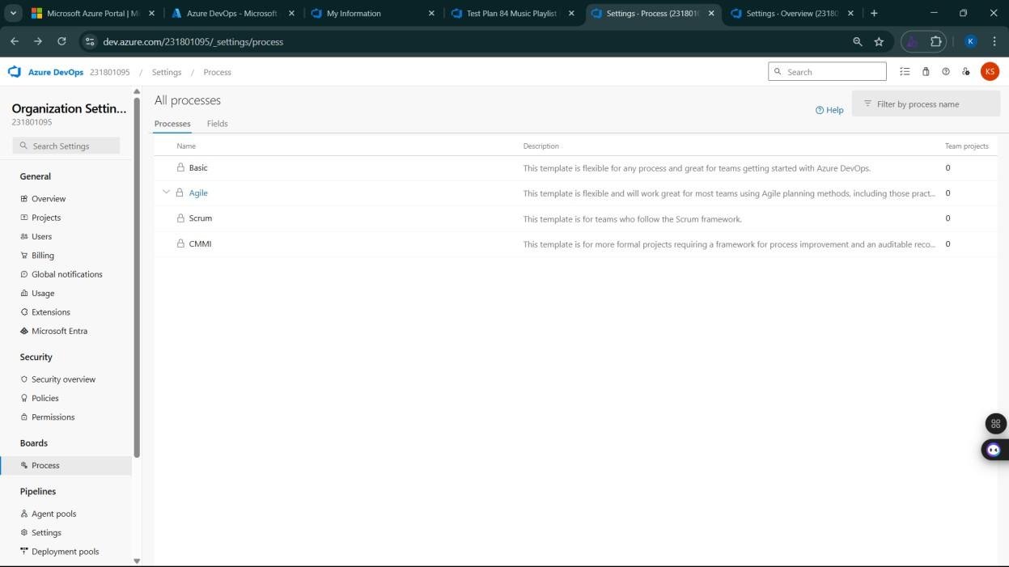

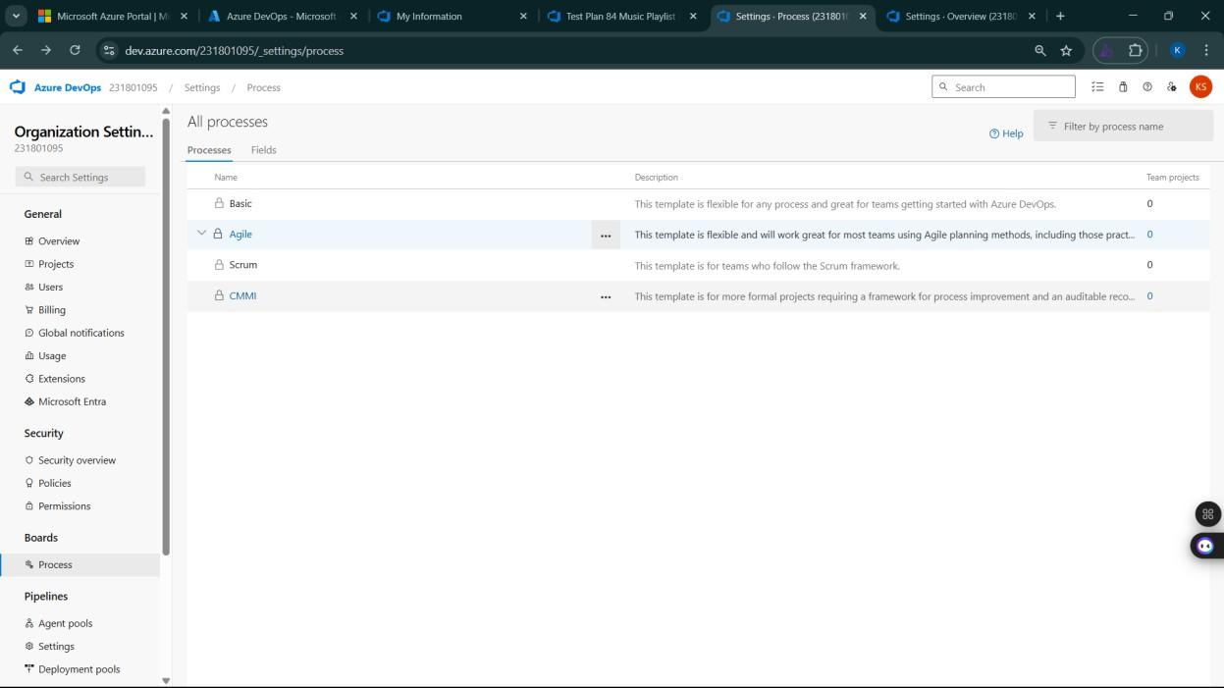

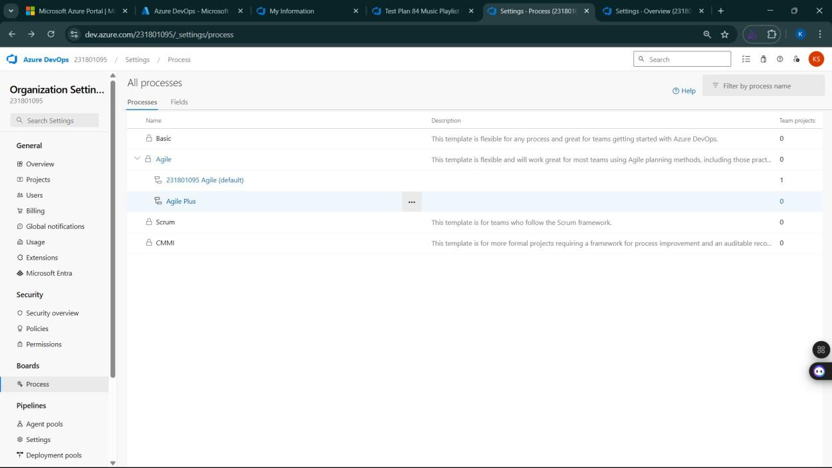

1. **View the new test case template**

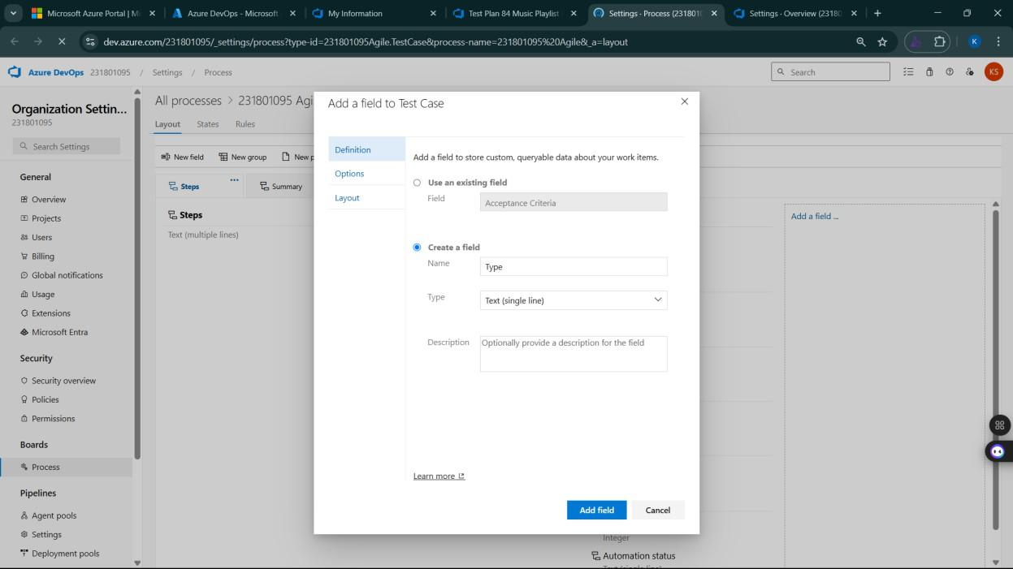

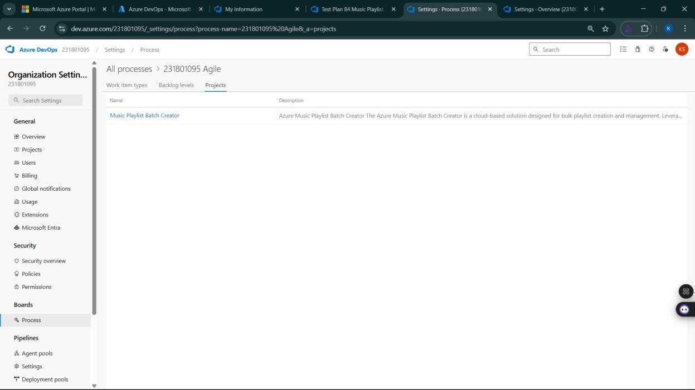

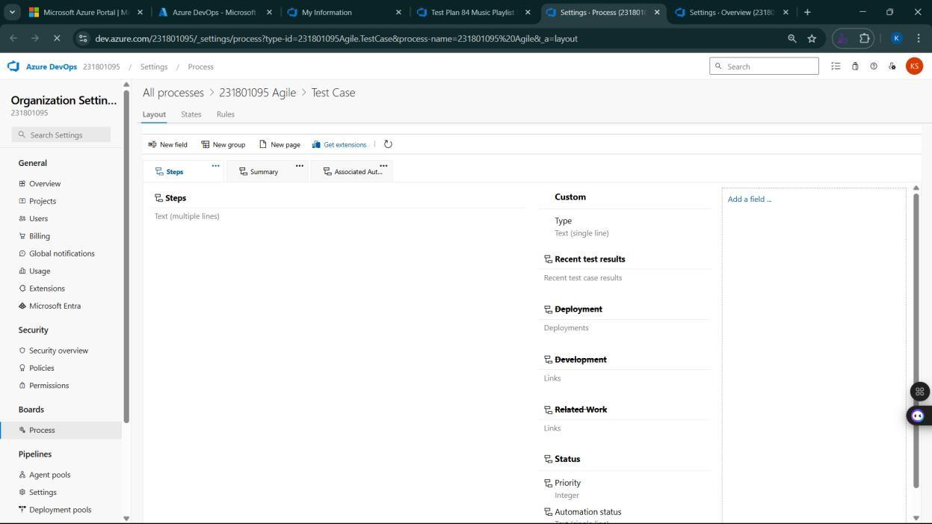

**Result:**

The test plans and test cases for the user stories is created in Azure DevOps with Happy Path and

Error Path



**Aim:**

To create an Azure Load Testing resource and run a load test to evaluate the performance of a target endpoint.

**Load Testing**

**Steps to Create an Azure Load Testing Resource:**

Before you run your first test, you need to create the Azure Load Testing resource:

1. Sign in to Azure Portal

Go to [https://portal.azure.com](https://portal.azure.com/) and log in.

1. Create the Resource
   * Go to *Create a resource* → Search for “Azure Load Testing”.
   * Select Azure Load Testing and click Create.
2. Fill in the Configuration Details
   * Subscriptio*n:* Choose your Azure subscription.
   * *Resource Group:* Create new or select an existing one.
   * *Name:* Provide a unique name (no special characters).
   * *Location:* Choose the region for hosting the resource.
3. (Optional) Configure tags for categorization and billing.
4. Click Review + Create, then Create.
5. Once deployment is complete, click Go to resource.

**Steps to Create and Run a Load Test:**

Once your resource is ready:

1. Go to your Azure Load Testing resource and click Add HTTP requests > Create. In
2. Basics Tab
   * *Test Name:* Provide a unique name.
   * *Description:* (Optional) Add test purpose.
   * *Run After Creation:* Keep checked.
3. Load Settings
   * *Test URL:* Enter the target endpoint (e.g., https://yourapi.com/products).
4. Click Review + Create → Create to start the test.

**Load Testing**

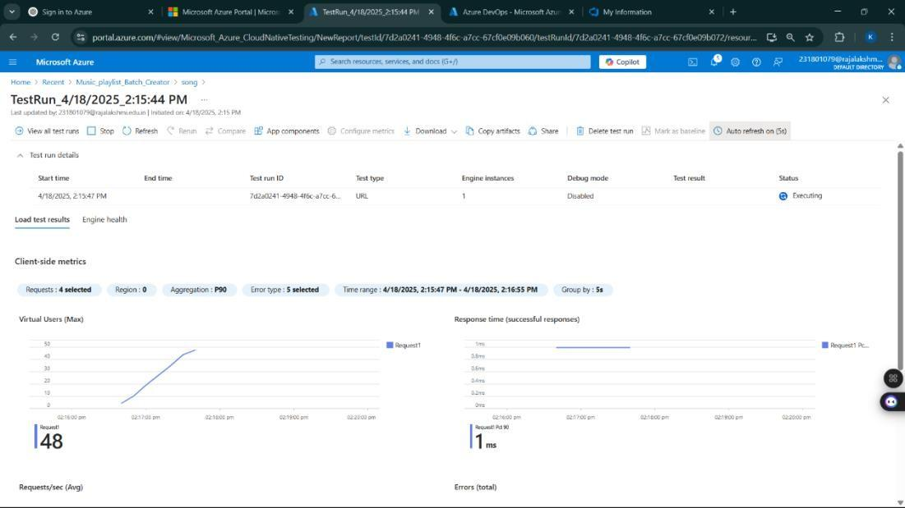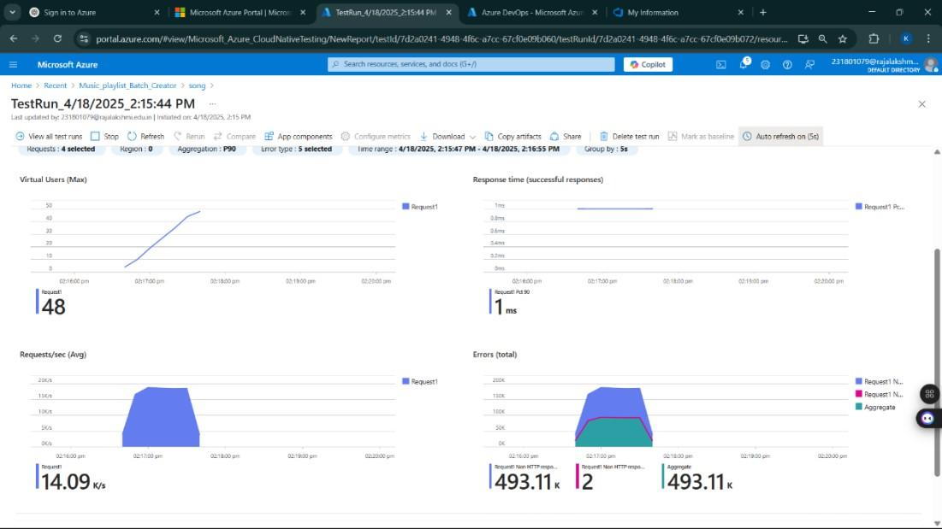

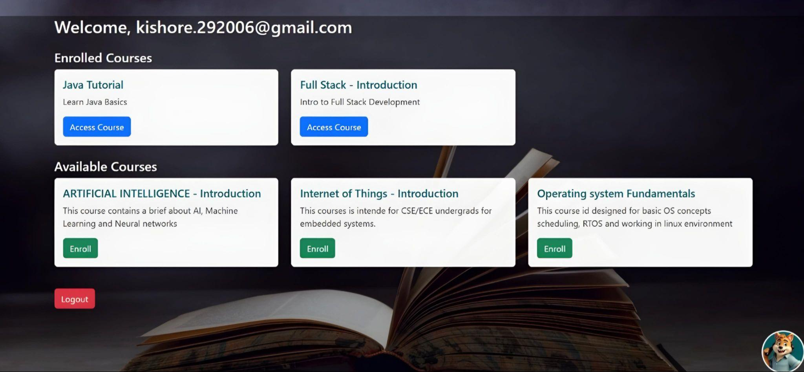

**Result:**

Successfully created the Azure Load Testing resource and executed a load test to assess the

performance of the specified endpoint.



**Aim:**

To provide a clear and organized view of the project's folder structure and file naming conventions, helping contributors and users easily understand, navigate, and extend the E-learning platform project.

**GitHub Project Structure**

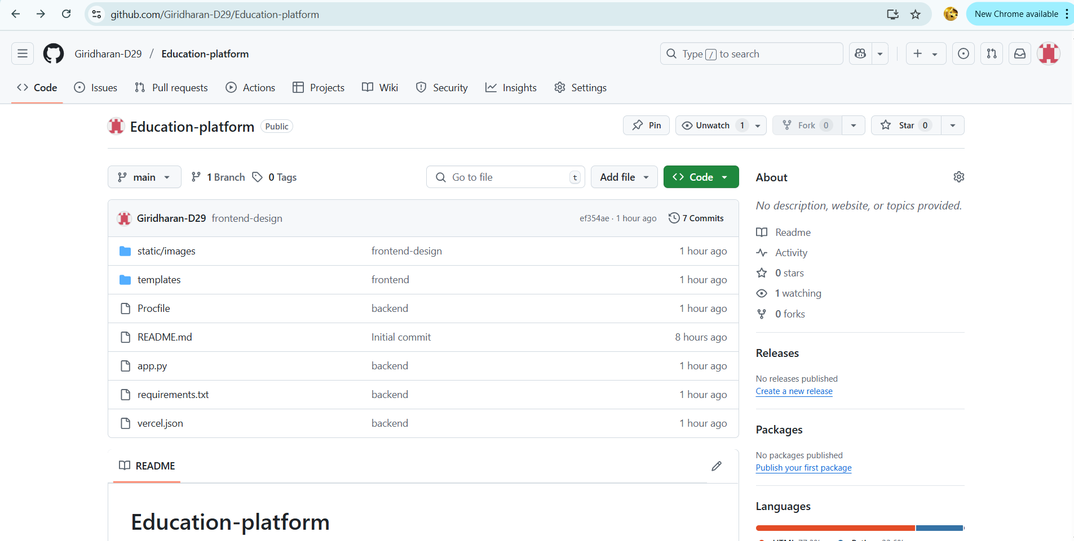

**Result:**

The GitHub repository clearly displays the organized project structure and consistent naming

conventions, making it easy for users and contributors to understand and navigate the codebase.